

【Announcements】
- We thank Mrs. Lisa Harper for sharing God’s word with us today.
- Sunny and Glennis Shih are in Philadelphia for the Epic East Coast Conference. Please pray for them as they minister to college students. Please also pray for Jeff Yu, Sunroot Liu, and Wen Gu as they attend this conference.

- Our Youth Fellowship will have a ‘concert of prayer’ on Friday, January 30th. Please join us for a time of praise & worship, followed by an extended time of prayer.

- Our Youth Fellowship will meet this Friday from 7:00 to 9:30. Every young person is welcome and encouraged to come. Rides are available.

- Our theme this year is “Be a Disciple, and Make Disciples”. The theme verse is Mt. 28:19-20.

- We welcome those who are here with us for the first time. We hope that you will continue to join us in worship in the future.

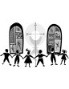
【Sunday Service Schedule】
Date/ Responsibility | 01/18/09 | 01/25/09
Speaker | Mrs. Lisa Harper | Mr. Joe Karlya
Presider* | Samantha Yu | Sunny Shih
Praise Team Leader** | Daniel Tan | Jeffrey Yu
Offertory Collector/Prayer | Torrance Pai | Lily Pan
Sound Board | Daniel Chen | Ken Wang
Power Point | Andrew Tan | Torrance Pai
Receptionist/Welcome | Sharon Yeung | Andrew Tan
Sunday School | Daniel Chen | Sunny Shih
*Presider needs to do: Call to Worship, Scripture Reading, and Announcements.
**Praise Team Leader needs to lead: Songs of Praise and Congregational Prayer.

Queens Taiwanese Evangelical Church
40-31 165th Street, Flushing, NY 11358
Week #3 Jan. 18, 2009

Theme of the Year
“Be a Disciple, and Make Disciples”

今年主題
【作門徒，帶門徒】

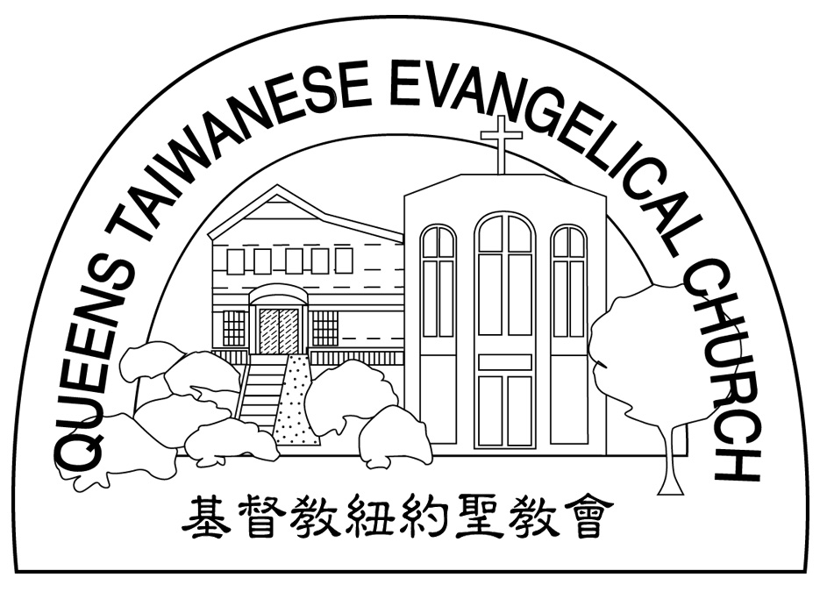
Verse of the Year主題金句
“Therefore go and make disciples of all nations,... teaching them to obey everything I have commanded you. And surely I am with you always, to the very end of the age.”
(Matthew 28:19-20)

Honored Pastor:高耀民牧師(Rev. Benjamin Kao) TEL: (718) 423-4550
Senior Pastor:尤陽生牧師(Rev. Johnson Yu) TEL: (718) 746-4199
Youth Director: 石松年弟兄(Sunny Shih) TEL:(518) 330-8447
Coworker of the Month:唐卓滿莉姊妹Mandy Chou) Tel:718-353-8610
Church Address: 40-31 165th Street Flushing, NY 11358
Church Website: www.qtecny.wtc.net
Church Telephone: (718)460-6326 ; FAX: (718)460-6326

Queens Taiwanese Evangelical Church
Week #3 Sunday Worship 01/18/2009

Presider: Samantha Yu Speaker: Mrs. Lisa Harper

Call to Worship………..…“Psalm 103:19-22” ………Samantha Yu
Songs of Praise……………………………………...Praise Team
Congregational Prayer…………..…………………Daniel Tan
Tithes & Offering……………………………………Torrance Pai
Scripture Reading………..“Mark 1:14-20”……………..… Samantha Yu
Sermon….….………..…“Follow Me”…….……....Lisa Harper
Song of Response ………………………….… Praise Team
Benediction…………………………………..….. Rev. Johnson Yu
Welcome & Announcements………………………Samantha Yu

Jesus said, "I am the light of the world. Whoever follows me will
never walk in darkness, but will have the light of life."
(John 8:12)
【Key Verse of the Week】

QTEC SUNDAY WORSHIP SERVICE 01/18/2009
Speaker: Mrs. Lisa Harper
Scripture: Mark 1:14-20
Sermon: “Follow Me”
Notes:

