

【Announcements】
- We thank Sunny Shih for sharing God’s word with us today.

- We welcome back all college students who are here with us during winter recess. Your presence means a lot to us, and we hope you will join us as often as possible.

- Campus Crusade for Christ is holding the annual Epic East Coast Conference for Asian American students on Jan. 16th to 19th. For more information please contact Glennis Shih.

- We will have a New Year’s Combined Service next Sunday (Jan. 4^{th)} at 10:15.

- Young Adult volunteers are needed for Youth Group. If you are over 18 and have a desire to serve and minister to junior high and high school students, please speak to Sunny Shih or Daniel Chen.

- Our Youth Group Officers for 2009 are Samantha Yu, Andrew Tan, and Daniel Tan. Please pray for them as they give their best to serve the Lord.

- Our theme for next year is “Be a Disciple, and Make Disciples”.

- Friday night 7:00-9:30 is our Youth fellowship and Bible study time. Every young person is welcome and encouraged to come. Rides are available.

- We welcome those who are here with us for the first time. We hope that you will continue to join us in worship in the future.


【Sunday Service Schedule】
Date/ Responsibility | 12/28/08 | 01/04/09
Speaker | Sunny Shih | Rev. Johnson Yu
Presider* | Daniel Chen | Combined Service
Praise Team Leader | Samantha Yu
Offertory Collector/Prayer | Andrew Tan
Sound Board/PowerPoint | Ken Wang
Receptionist/Welcome | Glennis Shih
Sunday School | Sunny Shih
*Presider needs to do: Call to Worship, Scripture Reading, and Announcements.
*Praise Team Leader needs to lead: Songs of Praise and Congregational Prayer.

Queens Taiwanese Evangelical Church
40-31 165th Street, Flushing, NY 11358
Week #52 Dec. 28, 2008

Theme of the Year
“Striving for the Gospel with One Mind”
今年主題
【齊 心 努 力 為 福 音】

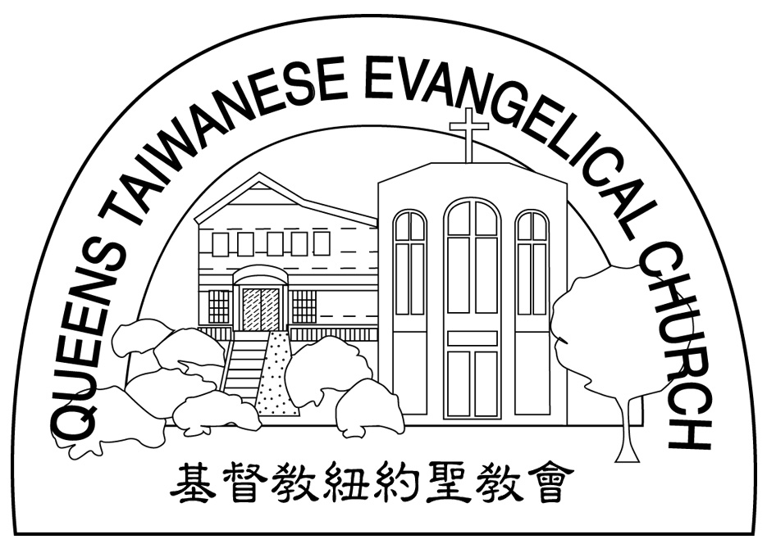
Verse of the Year主題金句
“Let your manner of life be worthy of the gospel of
Christ…standing firm in one spirit, with one mind
striving side by side for the faith of the gospel.”
(Philipians1:27)
「你們行事為人應當和基督的福音相配…有同一的心志，
站立得穩，為了福音的信仰齊心努力。」（腓立比書1:27)

Honored Pastor:高耀民牧師(Rev. Benjamin Kao) TEL: (718) 423-4550
Senior Pastor:尤陽生牧師(Rev. Johnson Yu) TEL: (718) 746-4199
Youth Director: 石松年弟兄(Sunny Shih) TEL:(518) 330-8447
Coworker of the Month:王志偉弟兄(ChiWei Wang) Tel:718-591-1946
Church Address: 40-31 165th Street Flushing, NY 11358
Church Website: www.qtecny.wtc.net
Church Telephone: (718)460-6326 ; FAX: (718)460-6326

Queens Taiwanese Evangelical Church
Week #52 Sunday Worship 12/28/2008

Presider: Daniel Chen Speaker: Sunny Shih

Call to Worship…………“Psalm 115:15-18” ………Daniel Chen
Songs of Praise……………………………………...Praise Team
Congregational Prayer…………..…………………Samantha Yu
Tithes & Offering……………………………………Andrew Tan
Testimony……………………………….………………Naomi Chen
Scripture Reading
“Genesis 11:26-12:3” “Matthew 5:13-16”……….…………Daniel Chen

Sermon….….….…“You are blessed”…..…..Sunny Shih
Song of Response …”Oh Lord My Heart Longs to be”… Praise Team
Benediction…………………………………..Rev. Johnson Yu
Welcome & Announcements………………………Daniel Chen
“In the same way, let your light shine before others, so that they
may see your good works and give glory to your Father who is
in heaven.”
(Matthew 5:16)
【Key Verse of the Week】

QTEC SUNDAY WORSHIP SERVICE 12/28/2008
Speaker: Sunny Shih
Scripture: “Genesis 11:26-12:3” “Matthew 5:13-16”
Sermon: “You are blessed”
Notes:
1. What did Abram do in order to be blessed by God?

2. How are all peoples of the earth blessed through Abraham?

3. Why does God bless people?

