

【Announcements】

- We will have a Combined Service next Sunday, November 30th at 10:15am. There will be no Sunday School.

- We are currently recruiting members for our Praise Team. If interested, please speak to Sunny Shih. Potential candidates must be will to commit at least 2 hours per week.

- Our 2nd Annual Thanksgiving Reunion Celebration is on Friday, November 28th, 2008. Join us for an evening of food, fun, and fellowship. Please RSVP by TODAY, Nov. 23rd, if planning to attend.

- There will be baptismal service on the Christmas Sunday Dec. 21. If you have accepted Jesus as your Savior and Lord, and are ready to be baptized, please contact Sunny Shih before Nov. 30 today.

- Youth Group is going Bowling on Friday, Dec. 5th. All are welcome to attend.

- Friday night 7:00-9:30 is our Youth fellowship and Bible study time. Everyone is welcome and encouraged to come.

- We welcome those who are here with us for the first time. We hope that you will continue to join us in worship in the future.


【Sunday Service Schedule】
Date/ Responsibility | 11/23/08 | 12/07/08
Speaker | Sunny Shih | Glennis Shih
Presider* | Rebecca Lin | Daniel Tan
Praise Team Leader | Daniel Tan | Sam Yu
Offertory Collector/Prayer | Andrew Tan | Andrew Tan
Sound Board/PowerPoint | Ken Wang | Ken Wang
Receptionist/Welcome | Lily Pan | Lily Pan
Sunday School | Sunny Shih | Sunny Shih

*Presider needs to do: Call to Worship, Scripture Reading, and Announcement.
*Praise Team Leader needs to lead: Songs of Praise and Congregational Prayer.

Queens Taiwanese Evangelical Church
40-31 165th Street, Flushing, NY 11358
Week #47 Nov. 23, 2008

Theme of the Year
“Striving for the Gospel with One Mind”
今年主題
【齊 心 努 力 為 福 音】

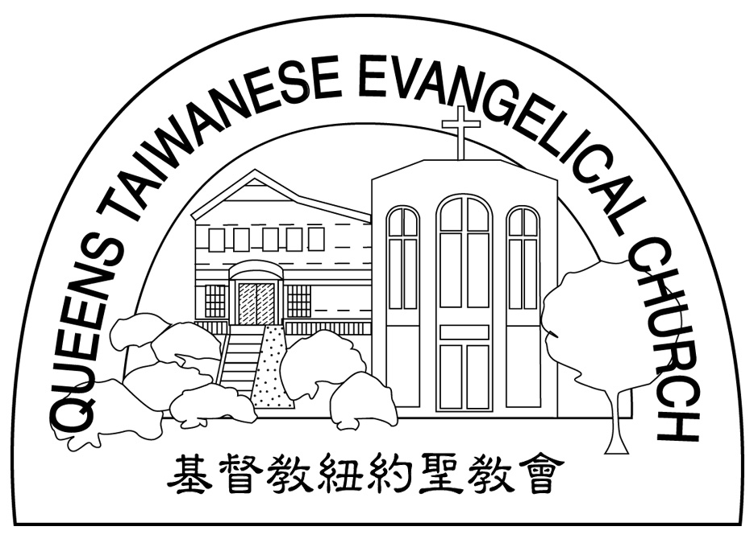
Verse of the Year主題金句
“Let your manner of life be worthy of the gospel of
Christ…standing firm in one spirit, with one mind
striving side by side for the faith of the gospel.”
(Philipians1:27)
「你們行事為人應當和基督的福音相配…有同一的心志，
站立得穩，為了福音的信仰齊心努力。」（腓立比書1:27)

Honored Pastor:高耀民牧師(Rev. Benjamin Kao) TEL: (718) 423-4550
Senior Pastor:尤陽生牧師(Rev. Johnson Yu) TEL: (718) 746-4199
Youth Director: 石松年弟兄(Sunny Shih) TEL:(518) 330-8447
Coworker of the Month:王志偉弟兄(ChiWei Wang) Tel:718-591-1946
Church Address: 40-31 165th Street Flushing, NY 11358
Church Website: www.qtecny.wtc.net
Church Telephone: (718)460-6326 ; FAX: (718)460-6326

Queens Taiwanese Evangelical Church
Week #47 Sunday Worship 11/23/2008

Presider: Rebecca Lin Speaker: Mr. Sunny Shih

Call to Worship…………“Psalm 103:8-12”………………Rebecca Lin
Songs of Praise……………………………………...Praise Team
Congregational Prayer…………..………………………Daniel Tan
Tithes & Offering……………………………………Andrew Tan
Scripture Reading……“Deuteronomy 6:20-25, Ephesians 2:1-10”… Rebecca Lin
Sermon…………………“By Grace Alone”……………Mr. Sunny Shih
Song of Response ……….. “Your Grace is Enough” ……Praise Team
Benediction………………………………Pastor Johnson Yu
Welcome & Announcements…………………Rebecca Lin

“ For by grace you have been saved through faith. And this is not
your own doing; it is the gift of God!” (Ephesians 2:8)
【Key Verse of the Week】

QTEC SUNDAY WORSHIP SERVICE
Week #47 11/23/2008 Speaker: Mr. Sunny Shih
Scripture: “Deuteronomy 6:20-25, Ephesians 2:1-10”
Sermon: “By Grace Alone”
Notes:
1. What are some worldly views of Christianity?

2. What is Grace?

3. What is the purpose of good works?

★Meditation:
As the Father has loved me, so have I loved you. Now remain in my love. -- John 15:9 (NIV)
★Quotation:
Jesus! why dost Thou love me so?
What hast Thou seen in me
To make my happiness so great,
So dear a joy to Thee?
... Fredrick William Faber (1814-1863)
_______________________________________________________

★Quiet time reflection:
Lord, You have loved me even though I have not loved You.

