

【Announcements】

- Sunny Shih (our new youth director) is doing first round visitations with all youth group students. If you are part of our youth fellowship or have desire to be part of our youth fellowship, please schedule an appointment with him before the end of December.

- Our 2nd Annual Thanksgiving Reunion Celebration is on Friday, November 28th, 2008. Join us for an evening of food, fun, and fellowship. Please RSVP by Nov. 23rd, if planning to attend.

- There will be baptismal service on the Christmas Sunday Dec. 21. If you have accepted Jesus as your Savior and Lord, and are ready to be baptized, please contact Sunny Shih before Nov. 30.

- Friday night 7:00-9:30 is our Youth fellowship and Bible study time. Every young person is welcome and encouraged to come.

- Our Thanksgiving Combined Worship Service will be on Nov. 30 at 10:15 am. Please note that those who are originally listed as service personnel on Nov. 30 have been moved to Nov. 23.
- We welcome those who are here with us for the first time. We hope that you will continue to join us in worship in the future.


【Sunday Service Schedule】
Date/ Responsibility | 11/16/08 | 11/23/08
Speaker | Rev. Johnson Yu | Sunny Shih
Presider* | Samantha Yu | Rebecca Lin
Praise Team Leader | Daniel Tan | Daniel Tan
Offertory Collector/Prayer | Ken Wang | Andrew Tan
Sound Board/PowerPoint | Andrew Tan | Ken Wang
Receptionist/Welcome | Ken Wang | Lily Pan
Sunday School | Sunny Shih | Sunny Shih

*Presider needs to do: Call to Worship, Scripture Reading, and Announcement.
*Praise Team Leader needs to lead: Songs of Praise and Congregational Prayer.

Queens Taiwanese Evangelical Church
40-31 165th Street, Flushing, NY 11358
Week #46 Nov. 16, 2008

Theme of the Year
“Striving for the Gospel with One Mind”
今年主題
【齊 心 努 力 為 福 音】

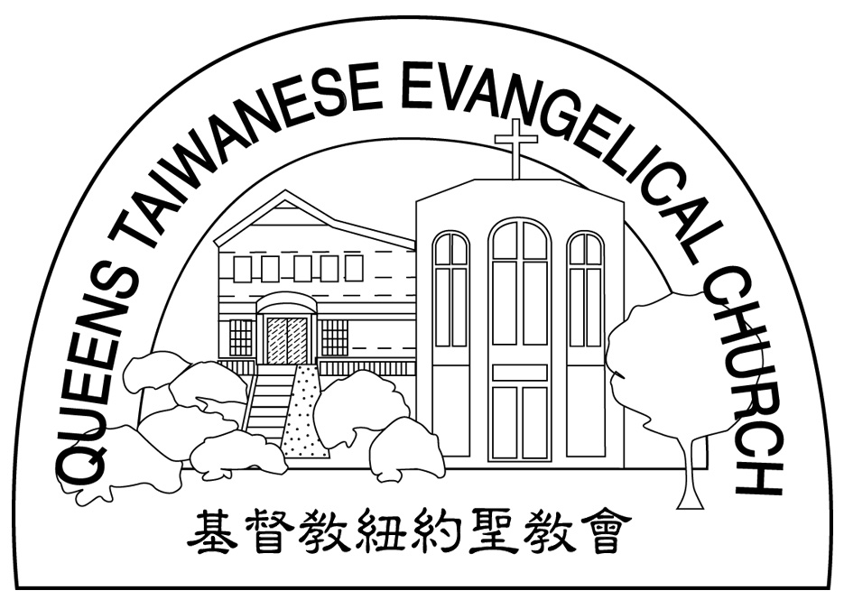
Verse of the Year主題金句
“Let your manner of life be worthy of the gospel of
Christ…standing firm in one spirit, with one mind
striving side by side for the faith of the gospel.”
(Philipians1:27)
「你們行事為人應當和基督的福音相配…有同一的心志，
站立得穩，為了福音的信仰齊心努力。」（腓立比書1:27)

Honored Pastor:高耀民牧師(Rev. Benjamin Kao) TEL: (718) 423-4550
Senior Pastor:尤陽生牧師(Rev. Johnson Yu) TEL: (718) 746-4199
Youth Director: 石松年弟兄(Sunny Shih) TEL:(518) 330-8447
Coworker of the Month:王志偉弟兄(ChiWei Wang) Tel:718-591-1946
Church Address: 40-31 165th Street Flushing, NY 11358
Church Website: www.qtecny.wtc.net
Church Telephone: (718)460-6326 ; FAX: (718)460-6326

Queens Taiwanese Evangelical Church
Week #46 Sunday Worship 11/16/2008

Presider: Samantha Yu Speaker: Pastor Johnson Yu

Call to Worship…………“Romans 5:1-2”………………Samantha Yu
Songs of Praise……………………………………...Praise Team
Congregational Prayer…………..………………………Daniel Tan
Tithes & Offering……………………………………Ken Wang
Scripture Reading……“Romans 3:23-25; 1 John 2:1-2; 4:10”……Samantha Yu
Sermon……“Resolving the Problem of Debt”……Pastor Johnson Yu
Song of Response …….. “Create in me a Clean Heart”……Praise Team
Communion…………………………………Pastor Johnson Yu
Benediction………………………………Pastor Johnson Yu
Welcome & Announcements…………………Sam Yu

“ In this is love, not that we have loved God but that he loved us and sent his Son to be the propitiation for our sins.!”(1 Jn. 4:10)
【Key Verse of the Week】

QTEC SUNDAY WORSHIP SERVICE 11/16/2008
Speaker: Pastor Johnson Yu
Scripture: “Romans 3:23-25; 1 John 2:1-2; 4:10”
Sermon: “Resolving the Problem of Debt”
Notes:
1. What is the debt and why?

2. Who pays the debt and how?

3. What is the outcome?

★Meditation:
The LORD reigneth; let the earth rejoice; let the multitude of isles be glad thereof. -- Psalm 97:1 (KJV)
_______________________________________________________
★Quiet time reflection:
Lord, help me to send the treasure of Christ in me to those who do not have it.


