

【Announcements】
- We thank Lin-fai Whu for sharing God’s word with us today.
- Mr. John Orchanian will be sharing with us on 11/8 and 11/15 on the topic of cults vs. Christianity.

- Communion Service of November will be held on 11/15. Please prepare yourself to remember Jesus our Lord’s redemptive grace and live for Him in whatever you do accordingly.

- Accountability groups and devotional materials are available for all youth group members. For more information, please contact a group leader or speak to Sunny Shih.

- Our College/Career group will have fellowship night this Friday at 6:30pm.

- Recreational Table Tennis is available on Saturday from 2:00 to 6:00.

- Please pray for the sick and the weary, and those who are going through difficult situations.

- We welcome those who are here with us for the first time, and those who are visiting. We hope that you will continue to join us in worship in the future.

【Sunday Service Schedule】
 | 11/01/09 | 11/08/09
Speaker | Mr. Lin-fai Whu | Mr. John Orchanian
Presider | Daniel Tan | Daniel Chen
Praise Team Leader | George Wang | George Wang
Scripture Reading | Andrew Tan | Daniel Tan
Offertory Collector | Lily Pan | Torrance Pai
Sound Board | Torrance Pai | Andrew Tan
PowerPoint | Ken Wang | Rachel Yeung
Receptionist/Welcome | Sharon Yeung | Ken Wang
Cleanup | Sunny Shih | Andrew Tan
Sunday School (Adult) | Daniel Chen | Daniel Chen
Sunday School (Youth) | Sunny Shih | Sunny Shih

Queens Taiwanese Evangelical Church
40-31 165th Street, Flushing, NY 11358
Week #44 Nov. 1, 2009

Theme of the Year
“Be a Disciple, and Make Disciples”

今年主題
【作門徒，帶門徒】
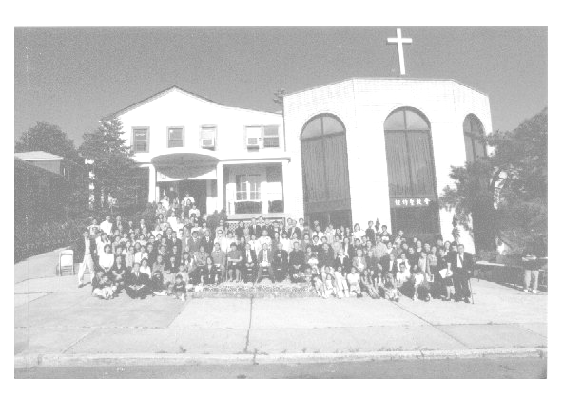

Verse of the Year主題金句
“Therefore go and make disciples of all nations,... teaching them to obey everything I have commanded you. And surely I am with you always, to the very end of the age.”
(Matthew 28:19-20)

Honored Pastor:高耀民牧師(Rev. Benjamin Kao) TEL: (718) 423-4550
Senior Pastor:尤陽生牧師(Rev. Johnson Yu) TEL: (718) 746-4199
English Ministry Director: (Sunny Shih) TEL:(518) 330-8447
Coworker of the Month: 唐卓滿莉姊妹 (Mandy Tong)TEL:718-353-8610
Church Address: 40-31 165th Street Flushing, NY 11358
Church Website: www.qtecny.wtc.net Church Telephone: (718)460-6326

Queens Taiwanese Evangelical Church
Week #44 Sunday Worship 11/01/2009

Presider: Daniel Tan Speaker: Lin-fai Whu

Call to Worship….…....“Psalm 29:1-4”……...…Daniel Tan
Songs of Praise………………………………….....Praise Team
Congregational Prayer…………………….………George Wang
Tithes & Offering………………………...……………..…..Lily Pan
Scripture Reading…………...… ”Isaiah 55”.…….…….. Andrew Tan

Sermon ..…“The Inerrancy and Infallibility of Scripture -II”…Lin-fai Whu
Song of Response …………………………..…... Praise Team
Closing Prayer……………………..…………….. Sunny Shih
Welcome & Announcements……………………Daniel Tan
【Key Verse of the Week】
“For the word of God is living and active, sharper than any
two-edged sword, piercing to the division of soul and of
spirit, of joints and of marrow, and discerning the thoughts
and intentions of the heart.”
(Hebrews 4:12)

ENGLISH WORSHIP SERVICE 11/01/2009
Speaker: Mr. Lin-fai Whu
“The Inerrancy and Infallibility of Scripture - II”
Scripture: “Isaiah 55”
Notes:

