

【Announcements】
- We thank Sunny Shih for sharing God’s word with us today.

- Accountability groups and devotional materials are available for all youth group members. For more information, please contact a group leader or speak to Sunny Shih.

- College/Career Fellowship will meet every Friday at 6:30pm. You may contact Daniel Chen for more information.

- We will begin distributing a quarterly newsletter starting next month. If you have any ideas or suggestions, please speak to Sarah Kim.

- Sunday School is available for all age groups at 10:30am.

- Please pray for the sick and the weary, and those who are going through difficult situations.

- We welcome those who are here with us for the first time. We hope that you will continue to join us in worship in the future.
【Sunday Service Schedule】
Date/ Responsibility | 10/11/09 | 10/18/09
Speaker | Sunny Shih | Glennis Shih
Presider | Daniel Chen | Daniel Tan
Praise Team Leader | Samantha Yu | Daniel Chen
Scripture Reading | Lily Pan | Andrew Tan
Offertory Collector | Ken Wang | Lily Pan
Sound Board | Andrew Tan | Torrance Pai
PowerPoint | Rachel Yeung | Ken Wang
Receptionist/Welcome | Sharon Yeung | Sunny Shih
Sunday School (Adult) | George Wang | TBA
Sunday School (Youth) | Sunny Shih | Sunny Shih

Queens Taiwanese Evangelical Church
40-31 165th Street, Flushing, NY 11358
Week #41 Oct. 11, 2009

Theme of the Year
“Be a Disciple, and Make Disciples”

今年主題
【作門徒，帶門徒】

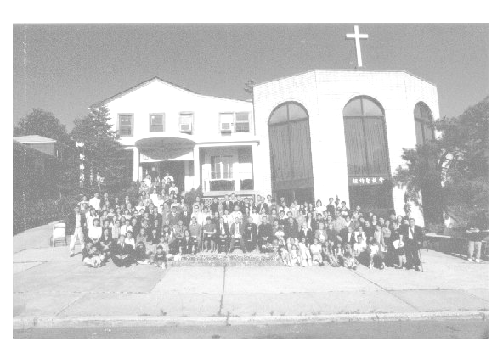
Verse of the Year主題金句
“Therefore go and make disciples of all nations,... teaching them to obey everything I have commanded you. And surely I am with you always, to the very end of the age.”
(Matthew 28:19-20)

Honored Pastor:高耀民牧師(Rev. Benjamin Kao) TEL: (718) 423-4550
Senior Pastor:尤陽生牧師(Rev. Johnson Yu) TEL: (718) 746-4199
English Ministry Director: (Sunny Shih) TEL:(518) 330-8447
Coworker of the Month: 孫瑞松弟兄 (Philip Sun) TEL:646-283-0050
Church Address: 40-31 165th Street Flushing, NY 11358
Church Website: www.qtecny.wtc.net
Church Telephone: (718)460-6326 ; FAX: (718)460-6326

Queens Taiwanese Evangelical Church
Week #41 Sunday Worship 10/11/2009

Presider: Daniel Chen Speaker: Sunny Shih

Call to Worship….…...“Psalm 29:10-11”….....…Daniel Chen
Songs of Praise………………………………….....Praise Team
Congregational Prayer…………………….……Samantha Yu
Tithes & Offering………………………...………………..Ken Wang
Scripture Reading
“Ephesians 4:17-23”, ”Matt. 5:9”…………….….………… Lily Pan

Sermon ….”Principles of Peacemaking”.… Sunny Shih
Song of Response …………………………..…... Praise Team
Communion…………………………………………….Pastor Yu
Doxology…………………………………………...Praise Team
Benediction……………………..…………….. Pastor Yu
Welcome & Announcements……………..……Daniel Chen
【Key Verse of the Week】
“May God himself, the God of peace, sanctify you through and
through. May your whole spirit, soul and body be kept
blameless at the coming of our Lord Jesus Christ.”
(1 Thessalonians 5:23)

ENGLISH WORSHIP SERVICE 10/11/2009
Speaker: Sunny Shih
“Principles of Peacemaking”
Scripture: ”Matt. 5:9”, “Eph. 4:17-23, 32” ,“Col. 3:12-17”
Notes:

