

【Announcements】
- We welcome those who are here with us for the first time. We hope that you will continue to join us in worship in the future.

- Let’s thank our speaker today Mr. Jeff Eichenlaub for bringing the message from God through His Word to edify our spiritual life. Mr. Eichenlaub is the Area Director of World Vision in New York.

- We will have special guest speaker Rev. Barth Chapman come to share with us on next Sunday. He and his wife are missionaries to Taiwan for more than twenty years.

- On Week of August 17, we have started the ‘Sharing from attending Youth Gospel Camp’ published in our bulletin each week, until all has been put up. Today we have Rebecca’s sharing.

- The church’s new website is officially underway. Feel free to visit www.qtecny.wtc.net. If you have anything that you would like to be uploaded on the site, please contact Richard Lin.

【Sunday Service Schedule】
Date/ Responsibility | 09/07/08 | 09/14/08
Speaker | Mr. Jeff Eichenlaub | Rev. Barth Chapman
Psalm / Scripture Reader | Sam Yu | Dan Tan
Announcement | SamYu | Dan Tan
Worship Leader/Song Book | Daniel Tan | Sam Yu
Congregational Prayer | Daniel Tan | Sam Yu
Offertory Collector/Prayer | Andrew Tan | Andrew Tan
Sound Board Tech./PowerPoint | Ken Wang | Ken Wang
Receptionist | Andrew Tan | Andrew Tan
Sunday School | Daniel Chen | Daniel Chen

Queens Taiwanese Evangelical Church
40-31 165th Street, Flushing, NY 11358
Week #36 Sept 7, 2008

Theme of the Year
“Striving for the Gospel with One Mind”
今年主題
【齊 心 努 力 為 福 音】

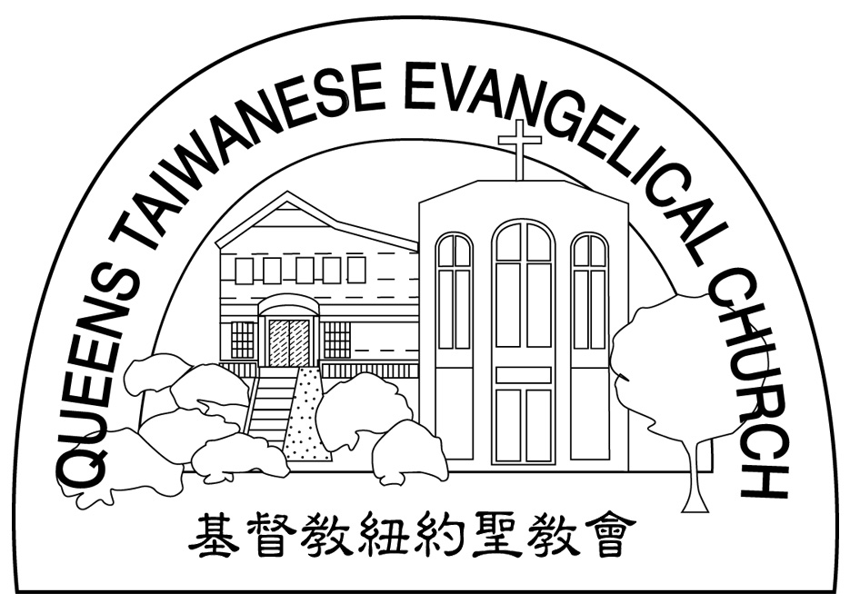
Verse of the Year主題金句
“Let your manner of life be worthy of the gospel of
Christ…standing firm in one spirit, with one mind
striving side by side for the faith of the gospel.”
(Philipians1:27)
「你們行事為人應當和基督的福音相配…有同一的心志，
站立得穩，為了福音的信仰齊心努力。」（腓立比書1:27)

Honored Pastor:高耀民牧師(Rev. Benjamin Kao) TEL: (718)423-4550
Senior Pastor:尤陽生牧師(Rev. Johnson Yu) TEL: (718)746-4199
Coworker of the Month: 高如珊姊妹(Kimberly Kao) TEL:646-251-9646
Church Address: 40-31 165th Street Flushing, NY 11358
Church Website: www.qtecny.wtc.net
Church Telephone: (718)460-6326 ; FAX: (718)460-6326

Queens Taiwanese Evangelical Church
Week #36 Sunday Worship 09/07/2008

Call to Worship………………………………………Daniel Tan

Songs of Praise………………………………………………Sam Yu

Congregational Prayer…………………………………………Sam Yu

Tithes & Offering…………………………………………Andrew Tan

Scripture Reading………………Luke 10:25-37……………Daniel Tan

Sermon………“Who is not my neighbor?”………Mr. Jeff Eichenlaub

Welcome & Announcements……………………Daniel Tan

Benediction…………………………………………Rev. Johnson Yu

Jesus answered: "Love the Lord your God with all your heart and with all your soul and with all your strength and with all your mind; and, Love your neighbor as yourself." ( Luke 10:27)
【Key Verse of the Week】

QTEC SUNDAY WORSHIP SERVICE 09/07/2008
Speaker: Mr. Jeff Eichenlaub

Sermon: “Who is not my neighbor?”
Scripture: Luke 10:25-37
Outlines:
1. Who is not my neighbor?

2. Why did the Godly leaders pass by?

3. Where do our obligations to our neighbors begin and end?

4. China earthquake relief update

_____________________________________________________________________________
Sharing from attending Youth Gospel Camp (2) Rebecca Lin

My experience at Grace Manor was one worth remembering. At first, I was worried about the success and overall impact that the retreat would have, since this was the first time that the youth group has arranged a retreat on its own. However, I ended up having lots of fun and learned about ‘being real’. I participated in in-depth discussions about the wide and narrow gates in life. In my small group, we shared thoughts and feelings about the sermons we were given. The retreat also helped me to get away from the routines of my daily life and forget about my current worries. I was also able to eat some delectable dishes. It was a great experience and I am looking forward to going there again next year.

