

【Announcements】
- We thank Lin-fai Whu for sharing God’s word with us today.
- Youth Group will have movie night tonight starting at 4:30pm.

- Next week we are back to 12:00 Sunday Worship Service.

- Please pray for all college students as they return to school and begin their fall semester.

- College/Career Group will meet this Friday for fellowship and Bible Study at 6:30pm.

- Sunday School is available for all age groups at 10:30am.

- We welcome those who are here with us for the first time. We hope that you will continue to join us in worship in the future.
【Sunday Service Schedule】
Date/ Responsibility | 08/30/09 | 09/06/09
Speaker | Mr. Lin-fai Whu | Rev. Doug Estella
Presider | Daniel Chen | Daniel Tan
Praise Team Leader | Jeffrey Yu | Samantha Yu
Scripture Reading | Glennis Shih | Glennis Shih
Offertory Collector | Torrance Pai | Torrance Pai
Sound Board | Ken Wang | Andrew Tan
PowerPoint | Andrew Tan | Sharon Yeung
Receptionist/Welcome | Sharon Yeung | Torrance Pai
Sunday School (Adult) | Grace Yeh | TBA
Sunday School (Youth) | Sunny Shih | Sunny Shih

Queens Taiwanese Evangelical Church
40-31 165th Street, Flushing, NY 11358
Week #35 Aug. 30, 2009

Theme of the Year
“Be a Disciple, and Make Disciples”

今年主題
【作門徒，帶門徒】

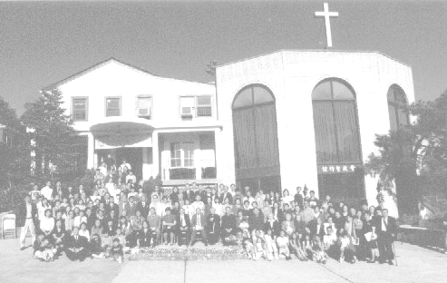
Verse of the Year主題金句
“Therefore go and make disciples of all nations,... teaching them to obey everything I have commanded you. And surely I am with you always, to the very end of the age.”
(Matthew 28:19-20)

Honored Pastor:高耀民牧師(Rev. Benjamin Kao) TEL: (718) 423-4550
Senior Pastor:尤陽生牧師(Rev. Johnson Yu) TEL: (718) 746-4199
English Ministry Director: (Sunny Shih) TEL:(518) 330-8447
Coworker of the Month: 高如珊(Kimberly Kao) TEL:718-357-5344
Church Address: 40-31 165th Street Flushing, NY 11358
Church Website: www.qtecny.wtc.net
Church Telephone: (718)460-6326 ; FAX: (718)460-6326

Queens Taiwanese Evangelical Church
Week #35 Sunday Worship 08/30/2009

Presider: Daniel Chen Speaker: Mr. Lin-fai Whu

Call to Worship….….“Romans 15:5-13”…...…Daniel Chen
Songs of Praise………………………………….....Praise Team
Congregational Prayer…………….……….……Jeffrey Yu
Tithes & Offering………………………...…………… Torrance Pai
Scripture Reading
“Romans 4:22-25”, “1 Cor. 10:1-13”…......…..…………… Glennis Shih

Sermon .”The Relevancy of the Scripture - Also Written for Us”. Lin-fai Whu
Song of Response …………………………..…... Praise Team
Benediction……………………..…………….. Pastor Yu
Welcome & Announcements……………………Daniel Chen
【Key Verse of the Week】
“For everything that was written in the past was written to
teach us, so that through endurance and the encouragement of
the Scriptures we might have hope.”
(Romans 15:4)

ENGLISH WORSHIP SERVICE 08/30/2009
Speaker: Lin-fai Whu
“The Relevancy of the Scripture - Also Written for Us”
Scripture: “Romans 4:22-25”, “1 Cor. 10:1-13”
Notes:

