

【Announcements】
- We welcome those who are here with us for the first time. We hope that you will continue to join us in worship in the future.

- There will be a whole church one day trip and picnic on the coming Saturday 8/23 to Sands Point Preserve in Port Washington. Whoever would like to go need to sign up for the arrangement of transportation. Please prepare your own lunch. We will meet at church at 8:30 am.

- There will be joint service on 8/31, including baptism and Communion, Whoever is ready to be baptized, please contact Pastor Yu before 8/24. Please prepare your heart to remember the Lord’s saving grace.

- The church’s new website is officially underway. Feel free to visit www.qtecny.wtc.net. If you have anything that you would like to be uploaded on the site, please contact Richard Lin.

【Sunday Service Schedule】
Date/ Responsibility | 08/17/08 | 08/24/08
Speaker | Rev. Johnson Yu | Rev. Johnson Yu
Psalm / Scripture Reader | Daniel Tan | Jeff Yu
Announcement | Daniel Tan | Jeff Yu
Worship Leader/Song Book | Sam Yu | Daniel Tan
Congregational Prayer | Sam Yu | Daniel Tan
Offertory Collector/Prayer | Abraham Lin | Andrew Tan
Sound Board Tech./PowerPoint | Ken Wang | Ken Wang
Receptionist | Lily Pan | Andrew Tan
Sunday School | Daniel Chen | Daniel Chen

Queens Taiwanese Evangelical Church
40-31 165th Street, Flushing, NY 11358
Week #33 Aug. 17, 2008

Theme of the Year
“Striving for the Gospel with One Mind”
今年主題
【齊 心 努 力 為 福 音】

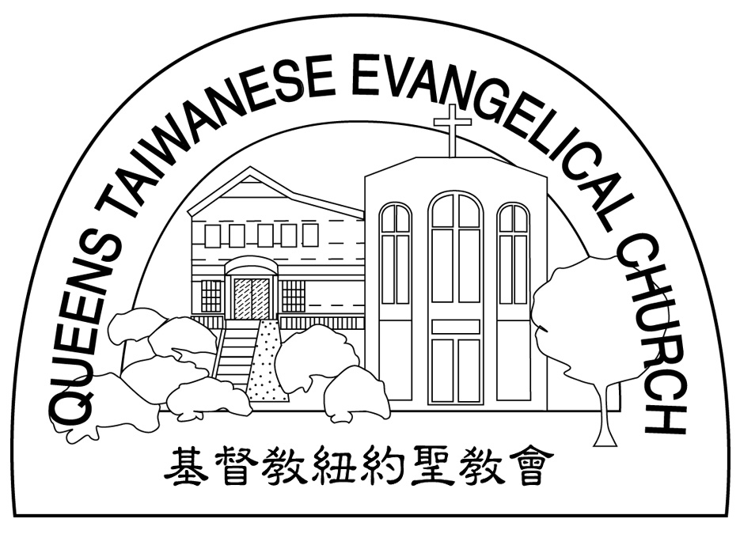
Verse of the Year主題金句
“Let your manner of life be worthy of the gospel of
Christ…standing firm in one spirit, with one mind
striving side by side for the faith of the gospel.”
(Philipians1:27)
「你們行事為人應當和基督的福音相配…有同一的心志，
站立得穩，為了福音的信仰齊心努力。」（腓立比書1:27)

Honored Pastor:高耀民牧師(Rev. Benjamin Kao) TEL: (718)423-4550
Senior Pastor:尤陽生牧師(Rev. Johnson Yu) TEL: (718)746-4199
Coworker of the Month: 陳林妙瑛姊妹(Lydia Chen) TEL:718-358-1057
Church Address: 40-31 165th Street Flushing, NY 11358
Church Website: www.qtecny.wtc.net
Church Telephone: (718)460-6326 ; FAX: (718)460-0539

Queens Taiwanese Evangelical Church
Week #33 Sunday Worship 08/17/2008

Call to Worship………………………………………Daniel Tan

Songs of Praise…………………………………………Samantha Yu

Congregational Prayer………………………………Samantha Yu

Tithes & Offering………………………………………Abraham Lin

Scripture Reading……「1 Cor. 9:24-27; Mt. 6:19-21」………Daniel Tan

Sermon……“Run for the Imperishable Medal”………Rev. Johnson Yu

Welcome & Announcements……………………Daniel Tan

Benediction…………………………………………Rev. Johnson Yu

“Every athlete exercises self-control in all things. They do it to receive a perishable wreath, but we an imperishable.” (1 Cor. 9:25)
【Key Verse of the Week】

QTEC SUNDAY WORSHIP SERVICE 08/10/2008
Speaker: Mr. Sunny Shih
Sermon: “Run for the Imperishable Medal”
Scripture: 1 Corinthians 9:24-27; Matthew 6:19-21
Outlines:
1. Do not run aimlessly, but lay up for yourselves treasures in heaven.

2. Exercises self-control in all things.

3. So run that you may obtain the prize, for where your treasure is,
there your heart will be also.

_____________________________________________________________________________
**
Meditation:
I know that everything God does will endure forever; nothing can be added to it and nothing taken from it. God does it so that men will revere him. Whatever is has already been, and what will be has been before; and God will call the past to account.
-- Ecclesiastes 3:14,15 (NIV)

________________________________________________________
**
Quiet time reflection:

Lord, You have saturated life with meaning, though we cannot see it.

