

【Announcements】
- We welcome those who are here with us for the first time. We hope that you will continue to join us in worship in the future.

- We thank Mr. Alex Thomas for his encouraging words from the Lord. He is an Inter Varsity staff worker with Nassau Community College Students.

- Summer’s approaching fast and a new service chart is on the way. Please speak to Naomi if you plan to be away during the summer beforehand so we can finish the summer service charts.

- We plan to have a Youth Gospel Camp during one weekend of early August. We are searching for available camp ground. Please begin to pray for the friends you want to invite, and pray for the whole work of preparation.

- The church’s new website is officially underway. Feel free to visit www.qtecny.wtc.net. If you have anything that you would like to be uploaded on the site, please contact Richard Lin.

【Sunday Service Schedule】
Date/ Responsibility | 06/15/08 | 06/22/08
Speaker | Mr. Alex Thomas | Mr. Howard Chan
Psalm / Scripture Reader | Joseph Lam | Jeff Kuo
Announcement | Joseph Lam | Jeff Kuo
Worship Leader/Song Book | Samantha Yu | Daniel Tan
Congregational Prayer | Samantha Yu | Daniel Tan
Offertory Collector/Prayer | Andrew Tan | Jennifer Kuo
Sound Board Tech./PowerPoint | Ken Wang | Ken Li
Receptionist | Naomi Chen | Lily Pan
Sunday School | Daniel Chen | Naomi Chen

Queens Taiwanese Evangelical Church
40-31 165th Street, Flushing, NY 11358
Week #24 June 15, 2008

Theme of the Year
“Striving for the Gospel with One Mind”
今年主題
【齊 心 努 力 為 福 音】

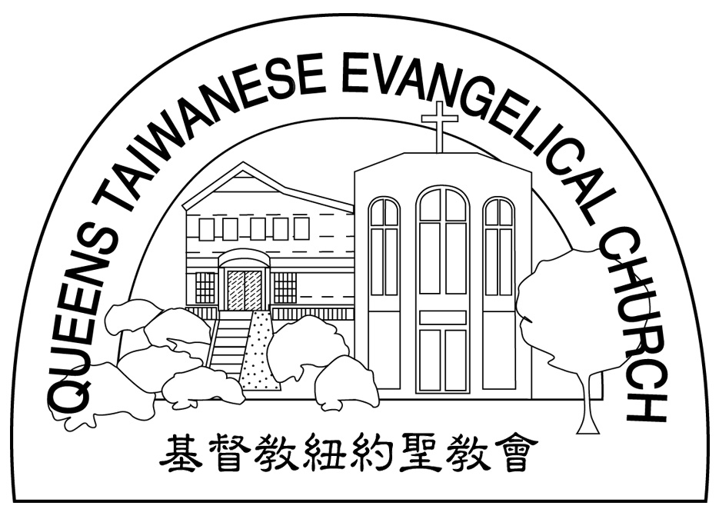
Verse of the Year主題金句
“Let your manner of life be worthy of the gospel of
Christ…standing firm in one spirit, with one mind
striving side by side for the faith of the gospel.”
(Philipians1:27)
「你們行事為人應當和基督的福音相配…有同一的心志，
站立得穩，為了福音的信仰齊心努力。」（腓立比書1:27)

Honored Pastor:高耀民牧師(Rev. Benjamin Kao) TEL: (718)423-4550
Senior Pastor:尤陽生牧師(Rev. Johnson Yu) TEL: (718)746-4199
Coworker of the Month: 孫瑞松弟兄(Philip Sun) TEL: 646-283-0050
Church Address: 40-31 165th Street Flushing, NY 11358
Church Website: www..qtecny.wtc.net
Church Telephone: (718)460-6326 ; FAX: (718)460-0539

Queens Taiwanese Evangelical Church
Week #23 Sunday Worship 06/15/2008

Call to Worship………………………………………Naomi Chen

Songs of Praise…………………………………………Samantha Yu

Congregational Prayer…………………………………Samantha Yu

Tithes & Offering………………………………………Andrew Tan

Scripture Reading…………Ephesians 4:21-32………Naomi Chen

Sermon…“Living in Accordance to the Gospel” …Mr. Alex Thomas

Welcome & Announcements……………………………Naomi Chen

Benediction…………………………………………Rev. Johnson Yu

“ Be renewed in the spirit of your minds, and to put on the new self, created after the likeness of God in true righteousness and holiness.” ( Ephesians 4:23-24)
【Key Verse of the Week】

QTEC SUNDAY WORSHIP SERVICE 06/15/2008
Speaker: Mr. Alex Thomas
Scripture: Ephesians 4:21-32
Sermon: “Living in Accordance to the Gospel”
Outline & Notes:

★Quotation:
There are... few stronger indications of ignorance of the power and evil of sin than the confident assertion of our ability to resist and subdue it.
... Charles Hedge
_____________________________________________________________________________
★ Meditation:
Watch and pray so that you will not fall into temptation.
The spirit is willing, but the body is weak.
-- Mark 14:38 (NIV)
_____________________________________________________________________________
★ Quiet time reflection:
Lord, grant that I may seek only You when in temptation.


