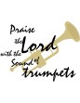

【Announcements】
- We welcome those who are here with us for the first time. We hope that you will continue to join us in worship in the future.

- Welcome those who are back from college. You are all encouraged to share your faith journey and life experiences on campus, so that we may grow together in the Lord.

- Next two Sundays 6/1 and 6/8 are all combined service. There will be Communion on 6/1, and a joint Sunday School class afterward. Pastor Yu will begin to teach the course “Basic Bible Study Method” on the Communion Sunday of each month.

- There will be church Member’s Meeting and election of new coworkers on 6/8 after the worship service. Please pray for it that God will choose His own faithful servants.

- Please continue to pray and care about those people who have suffered from earthquake in China and cyclone in Myanmar.

【Sunday Service Schedule】
Date/ Responsibility | 05/25/08 | 06/01/08
Speaker | Rev. Johnson Yu | Combined Service
Psalm / Scripture Reader | Joseph Lam
Announcement | Joseph Lam
Worship Leader/Song Book | Samantha Yu
Congregational Prayer | Samantha Yu
Offertory Collector/Prayer | Abraham Lin
Sound Board Tech./PowerPoint | Andrew Tan
Receptionist | Naomi Chen
Sunday School | Naomi Chen

Queens Taiwanese Evangelical Church
40-31 165th Street, Flushing, NY 11358
Week #21 May 25, 2008

Theme of the Year
“Striving for the Gospel with One Mind”
今年主題
【齊 心 努 力 為 福 音】

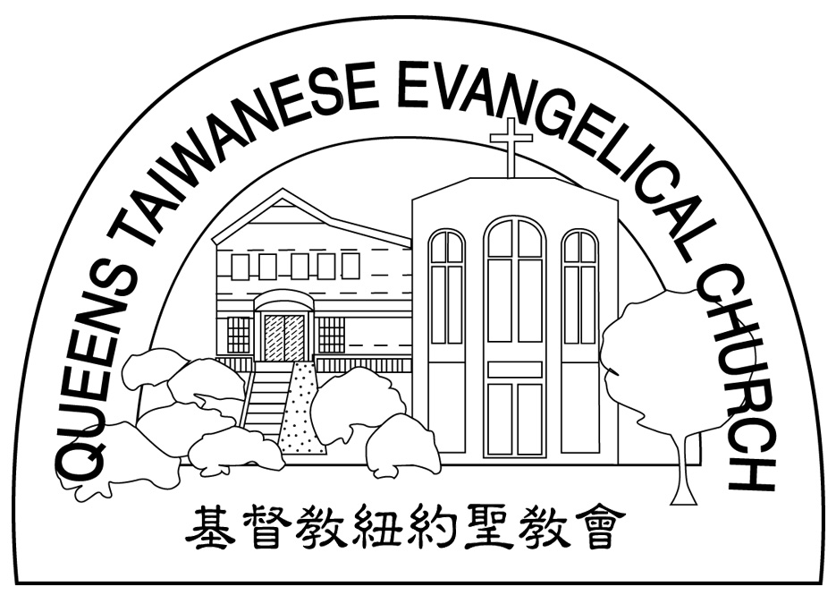
Verse of the Year主題金句
“Let your manner of life be worthy of the gospel of
Christ…standing firm in one spirit, with one mind
striving side by side for the faith of the gospel.”
(Philipians1:27)
「你們行事為人應當和基督的福音相配…有同一的心志，
站立得穩，為了福音的信仰齊心努力。」（腓立比書1:27)

Honored Pastor:高耀民牧師(Rev. Benjamin Kao) TEL: (718)423-4550
Senior Pastor:尤陽生牧師(Rev. Johnson Yu) TEL: (718)746-4199
Coworker of the Month: 張福民弟兄(Blue Chang)Tel: 718-428-3705
Church Address: 40-31 165th Street Flushing, NY 11358
Church Website: www..qtecny.wtc.net
Church Telephone: (718)460-6326 ; FAX: (718)460-0539

Queens Taiwanese Evangelical Church
Week #21 Sunday Worship 05/25/2008

Call to Worship…………………………………………Joseph Lam

Songs of Praise…………………………………………Samantha Yu

Congregational Prayer…………………………………Samantha Yu

Tithes & Offering………………………………………Abraham Lin

Scripture Reading………「Jn. 14:16-17; 16:12-15」……Joseph Lam

Sermon………“The Work of the Holy Spirit” ……Rev. Johnson Yu

Welcome & Announcements……………………………Joseph Lam

Benediction…………………………………………Rev. Johnson Yu

The Spirit of truth, whom the world cannot receive, because it neither sees him nor knows him. You know him, for he dwells with you and will be in you.” (Jn. 14:17)
【Key Verse of the Week】

QTEC SUNDAY WORSHIP SERVICE 05/25/2008
Speaker: Rev. Johnson Yu
Scripture: Jn. 14:16-17; 16:12-15
Sermon: The Work of the Holy Spirit
Outline & Notes:
1. Our life is between the physical and the spiritual world.

2. The Holy Spirit helps us to understand the spiritual things.

3. The Holy Spirit leads us to live out the spiritual truth.

★ Meditation:
Dear friends, now we are children of God, and what we will be has not yet been made known. But we know that when he appears, we shall be like him, for we shall see him as he is.
-- 1 John 3:2 (NIV)
_____________________________________________________________________________

★ Quiet time reflection:
Lord, You alone are my hope.

