

【Announcements】
- We thank Anna Lee-Winans for sharing God’s word with us today.
- Youth Group is having a Carwash and Bake sale fundraiser today after the worship service.
- All youth, this week is your last chance to register for the DCLA Youth Conference. Please register today!
- We will have Praise & Prayer on Friday, May 29th at 7:30pm. All who are interested in praying with us are welcome to join.
- Our summer retreat is on July 31st to Aug. 2nd. Please register before the end of the month for early bird discount.
- Praise Team practice is at 9:15 every Friday evening. We are always looking for those who want to use their musical abilities for the Lord. Those who are interested should speak to Sunny Shih.
- Recreational Table Tennis is available every Saturday from 2:00 to 6:00.

- Please pray for the sick and weary, and those who are going through difficult situations.

- We welcome those who are here with us for the first time. We hope that you will continue to join us in worship in the future.


【Sunday Service Schedule】
Date/ Responsibility | 05/17/09 | 05/24/09
Speaker | Anna Lee-Winans | Sunny Shih
Presider | Daniel Chen | Daniel Tan
Praise Team Leader | Samantha Yu | Samantha Yu
Offertory Collector | Torrance Pai | Lily Pan
Sound Board | Ken Wang | Torrance Pai
PowerPoint | Andrew Tan | Andrew Tan
Receptionist/Welcome | Lily Pan | Sharon Yeung
Sunday School | Sunny Shih | Sunny Shih
*Presider needs to do: Call to Worship, Scripture Reading, and Announcements.
**Praise Team Leader needs to lead: Songs of Praise and Congregational Prayer.

Queens Taiwanese Evangelical Church
40-31 165th Street, Flushing, NY 11358
Week #20 May 17, 2009

Theme of the Year
“Be a Disciple, and Make Disciples”

今年主題
【作門徒，帶門徒】

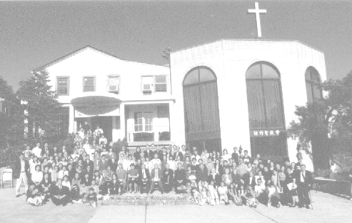
Verse of the Year主題金句
“Therefore go and make disciples of all nations,... teaching them to obey everything I have commanded you. And surely I am with you always, to the very end of the age.”
(Matthew 28:19-20)

Honored Pastor:高耀民牧師(Rev. Benjamin Kao) TEL: (718) 423-4550
Senior Pastor:尤陽生牧師(Rev. Johnson Yu) TEL: (718) 746-4199
Youth Director: 石松年弟兄(Sunny Shih) TEL:(518) 330-8447
Coworker of the Month: 王志偉弟兄(Chi-Wai Wang) TEL:718-591-1946
Church Address: 40-31 165th Street Flushing, NY 11358
Church Website: www.qtecny.wtc.net
Church Telephone: (718)460-6326 ; FAX: (718)460-6326

Queens Taiwanese Evangelical Church
Week #20 Sunday Worship 05/17/2009

Presider: Daniel Chen Speaker: Ms. Anna Lee-Winans

Call to Worship…………“Psalm 68:34-35” ….…...…Daniel Chen
Songs of Praise…………………………………..…...Praise Team
Congregational Prayer…………..…………………Samantha Yu
Tithes & Offering…………………………….. Torrance Pai
Scripture Reading……“Genesis 16:1-15”...….. Daniel Chen
Sermon…....“We Are Not What We Produce”…...Anna Lee-Winans
Song of Response …………………..……..…... Praise Team
Benediction……………………………..……….. Pastor Yu
Welcome & Announcements……………………Daniel Chen
【Key Verse of the Week】
“And we know that in all things God works for the good of those
who love him, who have been called according to his purpose.”
(Romans 8:28)

ENGLISH WORSHIP SERVICE 05/17/2009
Speaker: Ms. Anna Lee-Winans
Scripture: “Genesis 16” “Genesis 21:8-21”
Sermon: “We Are Not What We Produce”

Notes:

