

【Announcements】
- We welcome those who are here with us for the first time. We hope that you will continue to join us in worship in the future.

- Last Sunday’s presentations for Youth Sunday were a great success. Thanks to all who participated; let us keep striving for the gospel together with one mind.

- Next Sunday 5/11，there will be a combined worship for Mother’s Day and we will have guest speaker Mr. Stephen Fenchel from “The Chosen People Ministry，we encouraged to invite your parents to come and sit together while we worship to the Lord.

- On the week of 5/16-18, we will have a “Happy Marriage and Family Workshop”，the speakers are Mr. & Mrs. George & Linda Kuo，the topic they are going to share with us are the following at different schedule:

5/16 Friday 7:30pm-9:30pm

Dating, Marriage Preparation and Sexual Purity

(primarily English with some Mandarin)

5/17 Saturday 2:30pm-5:30pm

Communication and Resolving Marital Conflict (Mandarin)

5/17 Saturday 7:30pm-9:30pm

How to Teach Sex Education from Infant to Adult? (Mandarin)

5/18 Sunday10:15am-11:45am

The Pursuing Father (Mandarin & English)

5/18 Sunday12:00pm-13:00pm

Growing together with our children (Mandarin & English)
【Sunday Service Schedule】
Date/ Responsibility | 05/04/08 | 05/25/08
Speaker | Jainnie San Pedro | Henry Hwang
Psalm / Scripture Reader | Naomi Chen | Joseph Lam
Announcement | Naomi Chen | Joseph Lam
Worship Leader/Song Book | Daniel Tan | Samantha Yu
Congregational Prayer | Daniel Tan | Samantha Yu
Offertory Collector/Prayer | Abraham Lin | Abraham Lin
Sound Board Tech./PowerPoint | Andrew Tan | Andrew Tan
Receptionist | Abraham Lin | Naomi Chen
Sunday School | Naomi Chen | Naomi Chen

Queens Taiwanese Evangelical Church
40-31 165th Street, Flushing, NY 11358
Week #18 May 04, 2008

Theme of the Year
“Striving for the Gospel with One Mind”
今年主題
【齊 心 努 力 為 福 音】

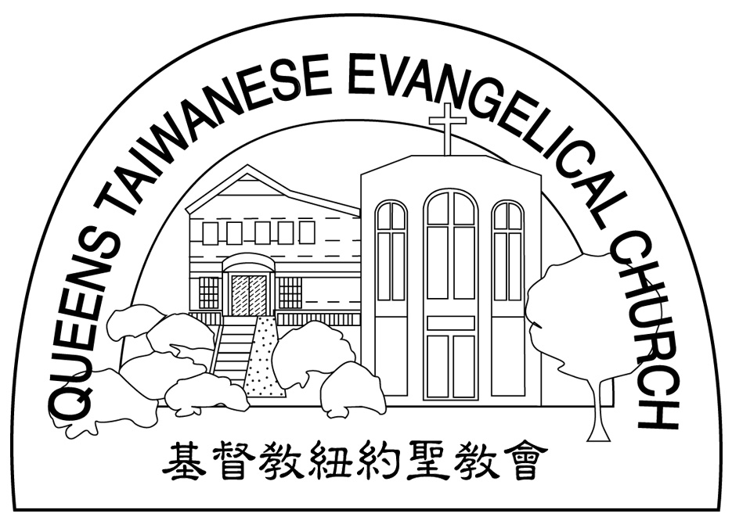
Verse of the Year主題金句
“Let your manner of life be worthy of the gospel of
Christ…standing firm in one spirit, with one mind
striving side by side for the faith of the gospel.”
(Philipians1:27)
「你們行事為人應當和基督的福音相配…有同一的心志，
站立得穩，為了福音的信仰齊心努力。」（腓立比書1:27)

Honored Pastor:高耀民牧師(Rev. Benjamin Kao) TEL: (718)423-4550
Senior Pastor:尤陽生牧師(Rev. Johnson Yu) TEL: (718)746-4199
Coworker of the Month: 張福民弟兄(Blue Chang)Tel: 718-428-3705
Church Address: 40-31 165th Street Flushing, NY 11358
Church Website: www..qtecny.wtc.net
Church Telephone: (718)460-6326 ; FAX: (718)460-0539

Queens Taiwanese Evangelical Church
Week #18 Sunday Worship 05/04/2008

Call to Worship…………………………………………Naomi Chen

Songs of Praise…………………………………………Daniel Tan

Congregational Prayer…………………………………Daniel Tan

Tithes & Offering………………………………………Abraham Lin

Scripture Reading………「Luke 24:1-50」……Naomi Chen

Sermon………“Your Emmaus Road” ………Ms. Jainnie San Pedro

Welcome & Announcements……………………………Naomi Chen

Benediction…………………………………………Rev. Johnson Yu

“I am going to send you what my Father has promised; but stay in the city until you have been clothed with power from on high.”
（Luke 24:48-49）
【Key Verse of the Week】

QTEC SUNDAY WORSHIP SERVICE 05/04/2008
Sermon: “Your Emmaus Road”
Scripture: Luke 24:1-50
Notes:

★ Meditation:
"Is not my word like fire," declares the LORD, "and like a hammer that breaks a rock in pieces?"
-- Jeremiah 23:29 (NIV)
_______________________________________________________________

★ Quiet time reflection:
Lord, burn my self-pity and indulgence out of me with Your holiness.

