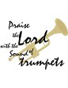

【Announcements】

- We are very thankful for Miss Anna Lee’s message. May God use her ministry to bless many. May God’s Word be our light of path.

- There is a new movie opens on this Friday April 17, the title is

“EXPELLED: No Intelligence Allowed.” It’s about the discovery that

scientists, educators and philosophers are being persecuted in a modern

day witch hunt, because they dare to go against the theory of evolution.

You will want to see this movie as a Christian who thinks sincerely.

- Next Sunday 1 P.M. Pastor Yu will be preaching at Long Island Christian Gospel Church in Stony Brook. We will be watching a DVD during the sermon time of our worship. The title is “Where Does the Evidence Lead?” It’s content is related to the movie mentioned above.

Please invite your good friends to come and see the DVD presentation.

- April 27 is Youth Sunday, and it will be a combined service. Please be prepared to participate in this special Sunday. We will do our preparation and practices after lunch in the lobby.

- We encourage all to come out to Friday night fellowships; we will also be doing preparation of Youth Sunday during those hours.

- On 5/3/08 Saturday, there will be Table Tennis Tournament held by FTCCNY. The table tennis practice is still going on every Saturday from 2-6pm, whoever is interested is welcome to join. Please see Richard Lin.

【Sunday Service Schedule】
Date/ Responsibility | 04/13/08 | 04/20/08
Speaker | Ms. Anna Lee | Media DVD
Psalm / Scripture Reader | Joseph Lam | Jeff Kuo
Announcement | Joseph Lam | Jeff Kuo
Worship Leader/Song Book | Daniel Tan | Daniel Tan
Congregational Prayer | Daniel Tan | Daniel Tan
Offertory Collector/Prayer | Abraham Lin | Jennifer Kuo
Sound Board Tech./PowerPoint | Ken Wang | Ken Wang
Receptionist | Naomi Chen | Jennifer Kuo
Sunday School | Naomi Chen | Naomi Chen

Queens Taiwanese Evangelical Church
40-31 165th Street, Flushing, NY 11358
Week #15 April 13, 2008

Theme of the Year
“Striving for the Gospel with One Mind”
今年主題
【齊 心 努 力 為 福 音】

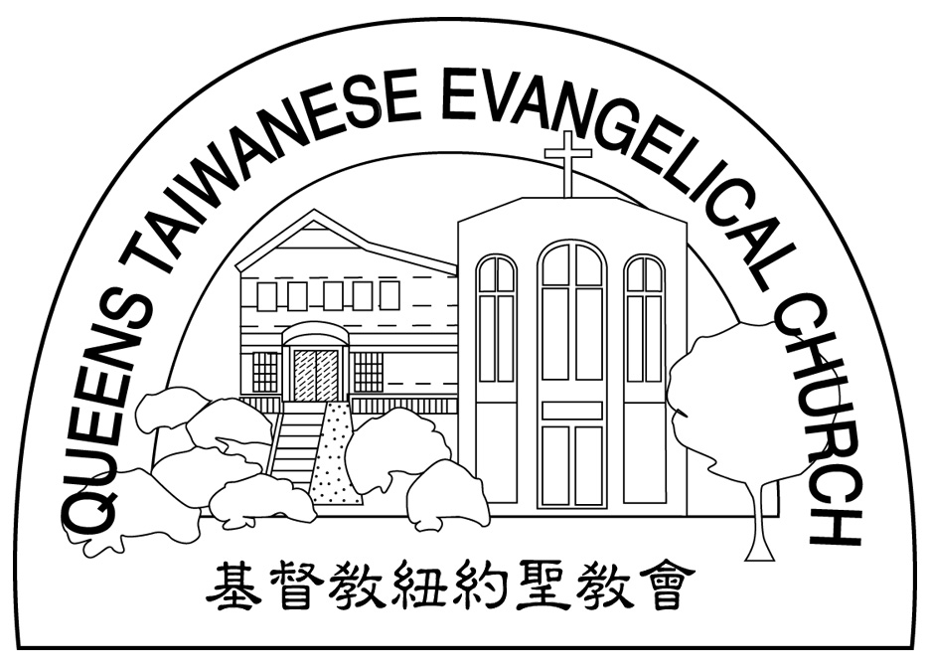
Verse of the Year主題金句
“Let your manner of life be worthy of the gospel of
Christ…standing firm in one spirit, with one mind
striving side by side for the faith of the gospel.”
(Philipians1:27)
「你們行事為人應當和基督的福音相配…有同一的心志，
站立得穩，為了福音的信仰齊心努力。」（腓立比書1:27)

Honored Pastor:高耀民牧師(Rev. Benjamin Kao) TEL: (718)423-4550
Senior Pastor:尤陽生牧師(Rev. Johnson Yu) TEL: (718)746-4199
Coworker of the Month:陳宜蓁Jennifer Chen TEL: (646)734-3086
Church Address: 40-31 165th Street Flushing, NY 11358
Church Website: www..qtecny.wtc.net
Church Telephone: (718)460-6326 ; FAX: (718)460-0539

Queens Taiwanese Evangelical Church
Week #15 Sunday Worship 04/13/2008

Call to Worship…………………………………………Joseph Lam

Songs of Praise…………………………………………Daniel Tan

Congregational Prayer…………………………………Daniel Tan

Tithes & Offering………………………………………Abraham Lin

Scripture Reading…………John 20:24-31……………Joseph Lam

Sermon……“Faithfully Engaging Doubt” ………Ms. Anna Lee

Welcome & Announcements……………………………Joseph Lam

Benediction…………………………………………Rev. Johnson Yu

Then Jesus told him, "Because you have seen me, you have believed; blessed are those who have not seen and yet have believed." （ John 20:29）
【Key Verse of the Week】

QTEC SUNDAY WORSHIP SERVICE 04/13/2008
Sermon Topic:
“Faithfully Engaging Doubt” by Ms. Anna Lee
Scripture: John 20:24-31
Sermon Notes:

★ Meditation:
Therefore I am sending you prophets and wise men and teachers. Some of them you will kill and crucify; others you will flog in your synagogues and pursue from town to town. And so upon you will come all the righteous blood that has been shed on earth, from the blood of righteous Abel to the blood of Zechariah son of Berekiah, whom you murdered between the temple and the altar. I tell you the truth, all this will come upon this generation.

-- Matthew 23:34-36 (NIV)
_______________________________________________________________
★ Quiet time reflection:
Lord, restore Your word to Your people.

