
【Announcements】
- We thank Joe Karlya for sharing God’s word with us today.
- The final score for the scavenger hunt is; George : 81, Sunny: 79, Daniel: 71. Please join us again next year!
- Congratulations to Michael Yu and Nicole Tsai on their engagement this past Friday!
- There will be “Group” Vacation Bible Camp training workshop on Sat. 4/24 9am-12pm at First Presbyterian Church, all are encouraged to attend.
- There will be discussion of preparation for our own church Vacation Bible Camp after lunch today. We need many youth and young adults’ help. All who will be available around 2nd half of August this year please join the discussion.
- There will be Outreach Bazaar on Sat. 5/8. Please pay attention to further info.
- If you are interested in preparing a meal for Friday night fellowship, please contact George Wang. All meal expenses are reimbursable.
- Our Youth and College/Career fellowship will meet this Friday at 6:30pm.
- Softball season will begin next month. Practice will be every Sunday at 3:30pm. At least 8 men and 3 women are needed. If you are interested, or know anyone who is interested, please let us know.
- Please pray for the sick and weary, and all those who are going through difficult situations.

- We welcome those who are here with us for the first time, and those who are visiting. We hope that you will continue to join us in worship in the future.

【Sunday Service Schedule】
 | 4/11/10 | 4/18/10
Speaker | Mr. Joe Karlya | Glennis Shih
Presider | Andrew Tan | Andrew Tan
Praise Team Leader | Daniel Chen | Jeffrey Yu
Scripture Reading | Rachel Yeung | Rachel Yeung
Offertory Collector | Torrance Pai | Samantha Yu
Sound Board | Ken Wang | Ken Wang
PowerPoint | Christine Li | Christine Li
Receptionist/Welcome | Sarah Kim | Lily Pan
Cleanup | Lily Pan | Sarah Kim
Sunday School (Adult) | Daniel Chen | Daniel Chen
Sunday School (Youth) | Sunny Shih | Sunny Shih

Queens Taiwanese Evangelical Church
40-31 165th Street, Flushing, NY 11358
Week #15 Apr. 11, 2010
Theme of the Year
“Deepen Worship, Vitalize Fellowship,
Strengthen Teamwork, Broaden Missions”
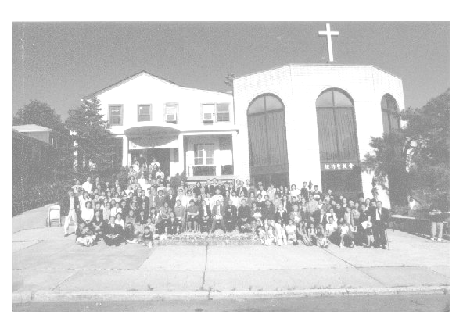

Verse of the Year
“And day by day, attending the temple together and breaking bread in their homes, they partook of food with glad and generous hearts, praising God and having favor with all the people. And the Lord added to their number day by day those who were being saved.” (Acts 2:46-47)

Honored Pastor:高耀民牧師(Rev. Benjamin Kao) TEL: (718) 423-4550
Senior Pastor:尤陽生牧師(Rev. Johnson Yu) TEL: (718) 746-4199
English Ministry Director: (Sunny Shih) TEL: (518) 330-8447
Coworker of the Month:高如珊姊妹(Kimberly Kao) TEL:(718) 357-5344
Church Address: 40-31 165th Street, Flushing, NY 11358
Church Telephone: (718)460-6326

Queens Taiwanese Evangelical Church
Week #15 Sunday Worship 4/11/2010
Presider: Andrew Tan Speaker: Mr. Joe Karlya

Call to Worship .….……...”Psalm 22:11-31”…........ Andrew Tan
Songs of Praise………………………………….....Praise Team
Congregational Prayer……………………………… Daniel Chen
Tithes & Offering………………….…..……………… Torrance Pai
Scripture Reading ……...…"John 20:19-23"…...……..… Rachel Yeung

Sermon …….“Our Response to the Resurrected Lord”.…...... Joe Karlya
Song of Response …………………………..…... Praise Team
Closing Prayer ……………………..………….……… Sunny Shih
Welcome & Announcements ……………………...… Andrew Tan
【Key Verse of the Week】
“But you will receive power when the Holy Spirit comes on you;
and you will be my witnesses in Jerusalem, and in all Judea and
Samaria, and to the ends of the earth”
(Acts 1:8)

ENGLISH WORSHIP SERVICE 4/11/2010
Speaker: Mr. Joe Karlya
“Our Response to the Resurrected Lord”
Scripture: "John 20:19-23”

Notes:

