
【Announcements】
- We thank John Orchanian for sharing God’s word with us today.

- Movie Night is tonight beginning at 5:00pm. We will be watching ‘Back to the Future’. Dinner will be provided.

- This week is the Passion Week. There will be Fasting Prayer time on Fri. Apr. 2 6:30-7:30 pm, followed by a special Passion Day Service at 7:45-9:00 pm. Please prepare yourself to respond to the Greatest Love.

- There will be a Baptismal service on Easter Sunday. If you feel you are ready to be baptized, please speak to Sunny Shih today.

- If you are interested in preparing a meal for Friday night fellowship, please contact George Wang. All meal expenses are reimbursable.

- Our Youth and College/Career fellowship will meet this Friday at 6:30pm.
- Please pray for the sick and weary, and all those who are going through difficult situations.


- We welcome those who are here with us for the first time, and those who are visiting. We hope that you will continue to join us in worship in the future.

【Sunday Service Schedule】
 | 3/28/10 | 4/04/10
Speaker | John Orchanian | Easter Sunday
Presider | George Wang | (Combined Service)
Praise Team Leader | Daniel Chen
Scripture Reading | Christine Li
Offertory Collector | Andrew Tan
Sound Board | Ken Wang
PowerPoint | Torrance Pai
Receptionist/Welcome | Lily Pan
Cleanup | Torrance Pai
Sunday School (Adult) | Daniel Chen
Sunday School (Youth) | Sunny Shih

Queens Taiwanese Evangelical Church
40-31 165th Street, Flushing, NY 11358
Week #13 Mar. 28, 2010
Theme of the Year
“Deepen Worship, Vitalize Fellowship,
Strengthen Teamwork, Broaden Missions”
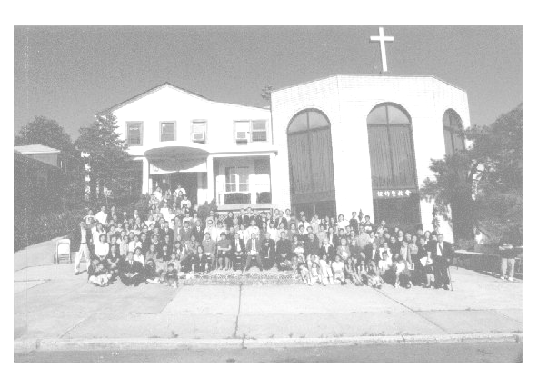

Verse of the Year
“And day by day, attending the temple together and breaking bread in their homes, they partook of food with glad and generous hearts, praising God and having favor with all the people. And the Lord added to their number day by day those who were being saved.” (Acts 2:46-47)

Honored Pastor:高耀民牧師(Rev. Benjamin Kao) TEL: (718) 423-4550
Senior Pastor:尤陽生牧師(Rev. Johnson Yu) TEL: (718) 746-4199
English Ministry Director: (Sunny Shih) TEL: (518) 330-8447
Coworker of the Month: 陳林妙瑛姊妹(Lydia Chen)
TEL: (718) 358-1057
Church Address: 40-31 165th Street, Flushing, NY 11358
Church Telephone: (718)460-6326

Queens Taiwanese Evangelical Church
Week #13 3/28/2010
Presider: George Wang Speaker: John Orchanian

Call to Worship .….……...”Romans 5:1-11”…...…..... George Wang
Songs of Praise………………………………….....Praise Team
Congregational Prayer……………………………… Daniel Chen
Tithes & Offering………………….…..………………… Andrew Tan
Scripture Reading …….…...…" Acts 1:3-9"…...……....… Christine Li

Sermon …………….“The Holy Spirit”.……........ John Orchanian
Song of Response …………………………..…... Praise Team
Closing Prayer ……………………..………….……… Sunny Shih
Welcome & Announcements ……………………...… George Wang

【Key Verse of the Week】
“But you will receive power when the Holy Spirit comes on you;
and you will be my witnesses in Jerusalem, and in all Judea and
Samaria, and to the ends of the earth”
(Acts 1:8)

ENGLISH WORSHIP SERVICE 3/28/2010
Speaker: Mr. John Orchanian
“The Holy Spirit”
Scripture: "John 14:15-17”, “John 16:7-11”, “Acts 1:8”

Notes:

