
【Announcements】
- We thank Sunny Shih for sharing God’s word with us today.

- There will be a Baptismal service this Easter. If you have accepted Jesus Christ as your Lord and Savior but have not been baptized, please speak to Sunny Shih as soon as possible.

- If you are interested in preparing a meal for Friday night fellowship, please contact George Wang. All meal expenses are reimbursable.

- We will have Fun Night this Friday (3/26). Please join us on our first annual scavenger hunt.

- We will have movie night next Sunday (3/28) beginning at 5:00pm.
- Please pray for the sick and weary, and all those who are going through difficult situations.

- We welcome those who are here with us for the first time, and those who are visiting. We hope that you will continue to join us in worship in the future.


【Sunday Service Schedule】
 | 3/21/10 | 3/28/10
Speaker | Sunny Shih | John Orchanian
Presider | Lily Pan | George Wang
Praise Team Leader | Samantha Yu | Daniel Chen
Scripture Reading | Christine Li | Christine Li
Offertory Collector | Rachel Chan | Andrew Tan
Sound Board | Andrew Tan | Ken Wang
PowerPoint | Alice Lee | Torrance Pai
Receptionist/Welcome |  | Lily Pan
Cleanup |  | Torrance Pai
Sunday School (Adult) |  | Daniel Chen
Sunday School (Youth) |  | Sunny Shih

Queens Taiwanese Evangelical Church
40-31 165th Street, Flushing, NY 11358
Week #12 Mar. 21, 2010
Theme of the Year
“Deepen Worship, Vitalize Fellowship,
Strengthen Teamwork, Broaden Missions”
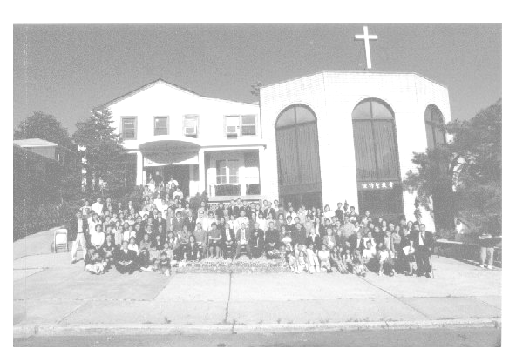

Verse of the Year
“And day by day, attending the temple together and breaking bread in their homes, they partook of food with glad and generous hearts, praising God and having favor with all the people. And the Lord added to their number day by day those who were being saved.” (Acts 2:46-47)

Honored Pastor:高耀民牧師(Rev. Benjamin Kao) TEL: (718) 423-4550
Senior Pastor:尤陽生牧師(Rev. Johnson Yu) TEL: (718) 746-4199
English Ministry Director: (Sunny Shih) TEL: (518) 330-8447
Coworker of the Month: 陳林妙瑛姊妹(Lydia Chen)
TEL: (718) 358-1057
Church Address: 40-31 165th Street, Flushing, NY 11358
Church Telephone: (718)460-6326

Queens Taiwanese Evangelical Church
Week #12 Youth Sunday 3/21/2010
Presider: Lily Pan Speaker: Sunny Shih

Welcome & Introduction……………………………….... Pastor Yu
Call to Worship .….……...”Psalm 62:5-8”…...…..... Lily Pan
Songs of Praise………………………………….... Praise Team
Congregational Prayer…………………….……… Samantha Yu
Testimonies …………….…..……… Christine Li, Sarah Kim, Ken Wang

Skit ………………………”The Pit”……………………..... Skit Team
Scripture Reading .…"Romans 5:1-5" “Hebrews 12:1-2”….. Christine Li

Sermon ….….“The Call To Persevere”.…... Sunny Shih
Song of Response …………………………..…... Praise Team
Offertory …………………….….…….… Rachel Chan, Rachel Yeung
Closing Remarks …………………………………..... Lily Pan
Doxology ……………………..………….…….… Together
Benediction ……………………..………….……… Pastor Yu
Announcements ……………………...…

Notes:

