

【Announcements】
- We thank Glennis Shih for sharing God’s word with us today.
- Our church will have a table tennis tournament on March 21st. Everyone is encouraged to participate. For more information please contact Richard Lin.
- Please pray for Samantha Yu as she recovers from a skin infection.
- Our Youth Fellowship meets every Friday at 6:30pm. Food is provided and rides are available. For more information please contact Sunny Shih.
- Youth Sunday School is available at 10:30am on the 3rd floor.

- English Communion Service will be held on March 22.
- DC2009 Youth Conference is from July 10th to 13th. Every youth (grades 7-12) is encouraged to attend. Financial aid will be available. For more information please contact Sunny Shih or visit (www.dcla2009.com).

- Sunny Shih will have office hours this Thursday from 4:00pm to 6:00pm. Please feel free to stop by and chat.

- We welcome those who are here with us for the first time. We hope that you will continue to join us in worship in the future.


【Sunday Service Schedule】
Date/ Responsibility | 03/08/09 | 03/15/09
Speaker | Glennis Shih | Sunny Shih
Worship Leader | Sunny Shih | TBA
Offertory Collector | Torrance Pai | Andrew Tan
Sound Board | Andrew Tan | Ken Wang
PowerPoint | Ken Wang | Torrance Pai
Receptionist/Welcome | Sharon Yeung | Daniel Chen
Sunday School | Sunny Shih | Sunny Shih
*Presider needs to do: Call to Worship, Scripture Reading, and Announcements.
**Praise Team Leader needs to lead: Songs of Praise and Congregational Prayer.

Queens Taiwanese Evangelical Church
40-31 165th Street, Flushing, NY 11358
Week #10 Mar. 08, 2009

Theme of the Year
“Be a Disciple, and Make Disciples”

今年主題
【作門徒，帶門徒】

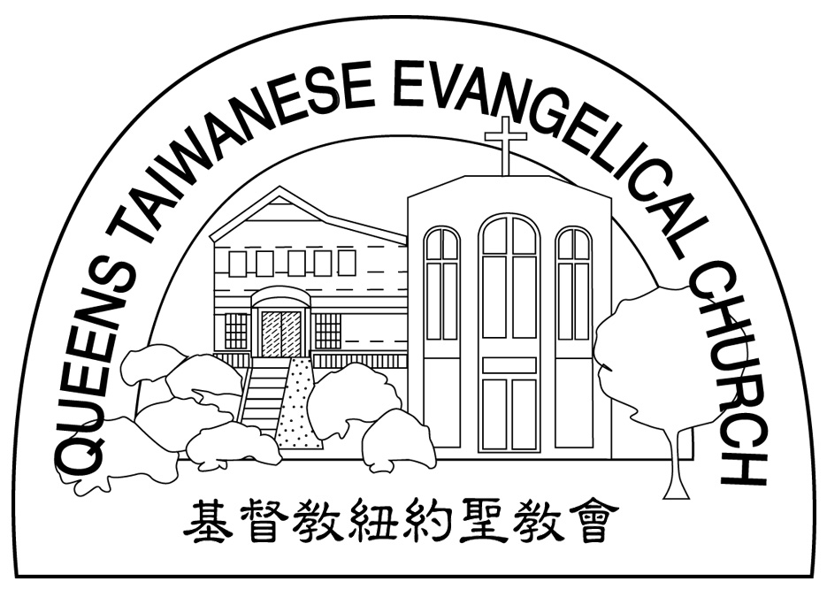
Verse of the Year主題金句
“Therefore go and make disciples of all nations,... teaching them to obey everything I have commanded you. And surely I am with you always, to the very end of the age.”
(Matthew 28:19-20)

Honored Pastor:高耀民牧師(Rev. Benjamin Kao) TEL: (718) 423-4550
Senior Pastor:尤陽生牧師(Rev. Johnson Yu) TEL: (718) 746-4199
Youth Director: 石松年弟兄(Sunny Shih) TEL:(518) 330-8447
Coworker of the Month:唐卓滿莉姊妹Mandy Chou) Tel:718-353-8610
Church Address: 40-31 165th Street Flushing, NY 11358
Church Website: www.qtecny.wtc.net
Church Telephone: (718)460-6326 ; FAX: (718)460-6326

Queens Taiwanese Evangelical Church
Week #10 Sunday Worship 03/08/2009

Presider: Sunny Shih Speaker: Glennis Shih

Call to Worship……….…“Psalm 9:1-2” ……….…Sunny Shih
Songs of Praise…………………………………..…...Praise Team
Congregational Prayer…………..………….…………Sunny Shih
Tithes & Offering…………………………………..……Torrance Pai
Scripture Reading
Genesis 22:1-19………..……….………………….……..Sunny Shih
Sermon…………….....“Faith Tested”….…….…….Glennis Shih
Song of Response ..…”Made Me Glad”….. Praise Team
Benediction……………………………..……….. Pastor Yu
Welcome & Announcements………………………Sunny Shih

【Key Verse of the Week】
“God redeemed us in order that the blessing given to Abraham
might come to all people through Christ Jesus, so that by faith
we might receive the promise of the Spirit.”
(Galatians 3:14)

QTEC SUNDAY WORSHIP SERVICE 03/08/2009
Speaker: Mrs. Glennis Shih
Scripture: Genesis 22:1-19
Sermon: “Faith Tested”
Notes:

