

【Announcements】
- We thank John Orchanian for sharing God’s word with us today.
- Our Youth Fellowship meets every Friday at 6:30pm. Food is provided and rides are available. For more information please contact Sunny Shih.
- Our church is having a table tennis tournament on March 21st. Everyone is encouraged to participate. For more information please contact Richard Lin.
- Pastor Yu is currently in Taiwan due to a personal family situation. Please remember them in your prayers.
- Youth Sunday School is available at 10:30am on the 3rd floor. English Adult Sunday School is also available. For more information please contact Glennis Shih (glennis.shih@gmail.com).
- DC2009 Youth Conference is from July 10th to 13th. Every youth (grades 7-12) is encouraged to attend. Financial aid will be available. For more information please contact Sunny Shih or visit (www.dcla2009.com).

- Sunny Shih has office hours every Thursday from 4:00pm to 6:00pm. Please feel free to stop by and chat.

- We welcome those who are here with us for the first time. We hope that you will continue to join us in worship in the future.


【Sunday Service Schedule】
Date/ Responsibility | 03/01/09 | 03/08/09
Speaker | John Orchanian | Glennis Shih
Worship Leader | Sunny Shih | Sunny Shih
Offertory Collector | Torrance Pai | Torrance Pai
Sound Board | Andrew Tan | Andrew Tan
PowerPoint | Ken Wang | Ken Wang
Receptionist/Welcome | Sharon Yeung | Sharon Yeung
Sunday School | Sunny Shih | Sunny Shih
*Presider needs to do: Call to Worship, Scripture Reading, and Announcements.
**Praise Team Leader needs to lead: Songs of Praise and Congregational Prayer.

Queens Taiwanese Evangelical Church
40-31 165th Street, Flushing, NY 11358
Week #9 Mar. 01, 2009

Theme of the Year
“Be a Disciple, and Make Disciples”

今年主題
【作門徒，帶門徒】

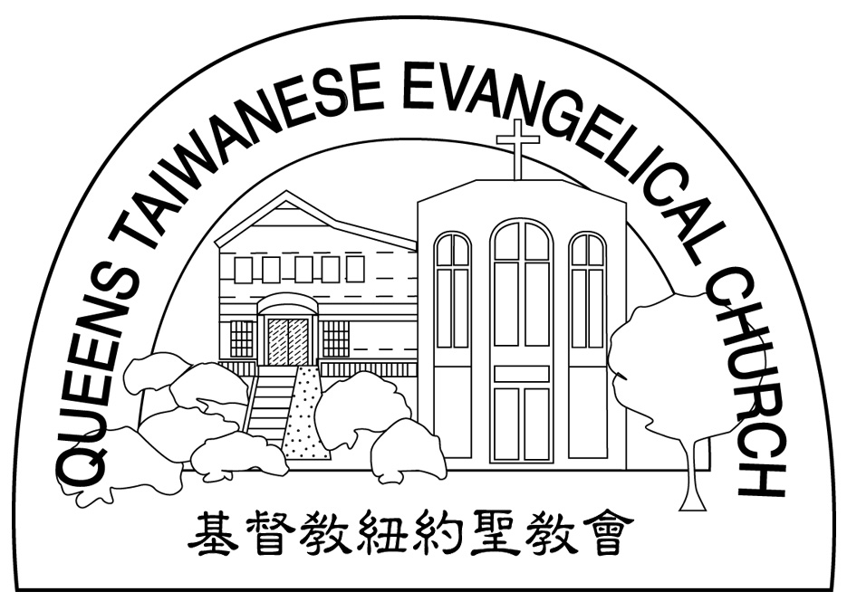
Verse of the Year主題金句
“Therefore go and make disciples of all nations,... teaching them to obey everything I have commanded you. And surely I am with you always, to the very end of the age.”
(Matthew 28:19-20)

Honored Pastor:高耀民牧師(Rev. Benjamin Kao) TEL: (718) 423-4550
Senior Pastor:尤陽生牧師(Rev. Johnson Yu) TEL: (718) 746-4199
Youth Director: 石松年弟兄(Sunny Shih) TEL:(518) 330-8447
Coworker of the Month:唐卓滿莉姊妹Mandy Chou) Tel:718-353-8610
Church Address: 40-31 165th Street Flushing, NY 11358
Church Website: www.qtecny.wtc.net
Church Telephone: (718)460-6326 ; FAX: (718)460-6326

Queens Taiwanese Evangelical Church
Week #9 Sunday Worship 03/01/2009

Presider: Sunny Shih Speaker: Mr. John Orchanian

Call to Worship……….…“Psalm 57:9-11” ……….…Sunny Shih
Songs of Praise…………………………………..…...Praise Team
Congregational Prayer…………..………….…………Sunny Shih
Tithes & Offering…………………………………..……Torrance Pai
Scripture Reading
Ezekiel 18:20, John 8:21……….………………….……..Sunny Shih
Sermon…………....“What is Sin?”………….John Orchanian
Song of Response ..…”Create in Me a Clean Heart”….. Praise Team
Closing Prayer……………………………..……….. Sunny Shih
Welcome & Announcements………………………Sunny Shih

【Key Verse of the Week】
“For the wages of sin is death, but the free gift of God
is eternal life in Christ Jesus our Lord.”
(Romans 6:23)

QTEC SUNDAY WORSHIP SERVICE 03/01/2009
Speaker: Mr. John Orchanian
Scripture: Ezekiel 18:20, John 8:21
Sermon: “What is Sin?”
Notes:

