

【Announcements】
- We thank Timothy Chen for sharing God’s word with us today.
- Pastor Yu is will be in Taiwan for 3 weeks due to a personal family situation. Please remember them in your prayers.
- Our Youth Fellowship meets every Friday at 6:30pm. Food is provided, followed by Bible Study and fellowship. If you need a ride please contact Richard Lin or Sunny Shih.
- Youth Sunday School is available at 10:30am on the 3rd floor. English Adult Sunday School is also available. For more information please contact Glennis Shih (glennis.shih@gmail.com).

- Please pray for the Jane Hyun outreach event at Columbia University. Jane is the author of Breaking the Bamboo Ceiling. She will be talking about career strategies for Asians and sharing her faith in the discussion. All are welcome.
- DC2009 Youth Conference is from July 10th to 13th. Every youth (grades 7-12) is encouraged to attend. Financial aid will be available. For more information please contact Sunny Shih or visit (www.dcla2009.com).

- Sunny Shih will have office hours every Thursday from 4:00pm to 6:00pm. Please feel free to stop by and chat.

- We welcome those who are here with us for the first time. We hope that you will continue to join us in worship in the future.


【Sunday Service Schedule】
Date/ Responsibility | 02/15/09 | 02/22/09
Speaker | Rev. Tim Chen | Glennis Shih
Presider* | Daniel Tan | Daniel Tan
Praise Team Leader** | Daniel Chen | Samantha Yu
Offertory Collector | Glennis Shih | Andrew Tan
Sound Board | Andrew Tan | Daniel Chen
Power Point | Torrance Pai | Torrance Pai
Receptionist/Welcome | Sharon Yeung | Sunny Shih
Sunday School | Sunny Shih | Sunny Shih
*Presider needs to do: Call to Worship, Scripture Reading, and Announcements.
**Praise Team Leader needs to lead: Songs of Praise and Congregational Prayer.

Queens Taiwanese Evangelical Church
40-31 165th Street, Flushing, NY 11358
Week #7 Feb. 15, 2009

Theme of the Year
“Be a Disciple, and Make Disciples”

今年主題
【作門徒，帶門徒】

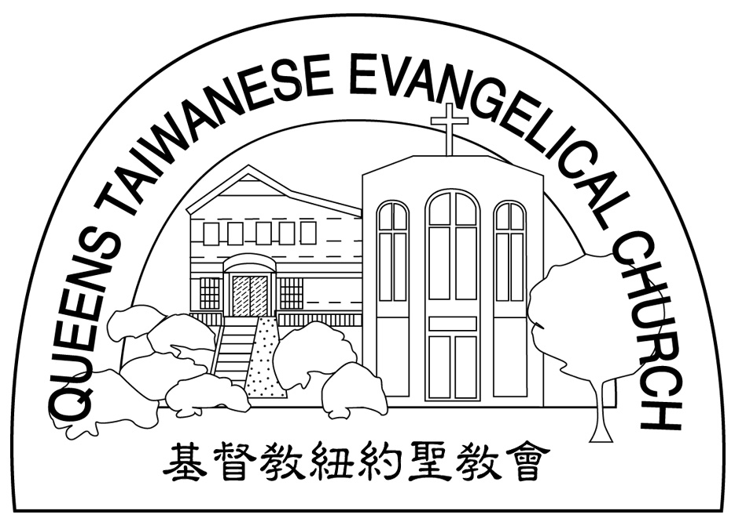
Verse of the Year主題金句
“Therefore go and make disciples of all nations,... teaching them to obey everything I have commanded you. And surely I am with you always, to the very end of the age.”
(Matthew 28:19-20)

Honored Pastor:高耀民牧師(Rev. Benjamin Kao) TEL: (718) 423-4550
Senior Pastor:尤陽生牧師(Rev. Johnson Yu) TEL: (718) 746-4199
Youth Director: 石松年弟兄(Sunny Shih) TEL:(518) 330-8447
Coworker of the Month:唐卓滿莉姊妹Mandy Chou) Tel:718-353-8610
Church Address: 40-31 165th Street Flushing, NY 11358
Church Website: www.qtecny.wtc.net
Church Telephone: (718)460-6326 ; FAX: (718)460-6326

Queens Taiwanese Evangelical Church
Week #7 Sunday Worship 02/15/2009

Presider: Daniel Tan Speaker: Rev. Timothy Chen

Call to Worship……….…“Psalm 111:1-10” ……….…Daniel Tan
Songs of Praise……………………………………...Praise Team
Congregational Prayer…………..…………….………Daniel Chen
Tithes & Offering…………………………………..……Glennis Shih
Scripture Reading
1 Corinthians 1:18-31, ………………….…….……..Daniel Tan
Sermon…..“When Wisdom is Foolishness”…...Rev. Timothy Chen
Song of Response ……”Sweet Mercies”…….… Praise Team
Benediction……………………………..….. Rev. Timothy Chen
Welcome & Announcements………………………Daniel Tan

【Key Verse of the Week】
“For the message of the cross is foolishness to those who are
perishing, but to us who are being saved it is the power of God..”
(1 Corinthians 1:18)

QTEC SUNDAY WORSHIP SERVICE 02/15/2009
Speaker: Rev. Timothy Chen
Scripture: 1 Corinthians 1:18-31
Sermon: “When Wisdom is Foolishness”
Notes:

