

【Announcements】
- We thank Mr. Joe Karlya for sharing God’s word with us today.
- Our Youth Fellowship will have a ‘concert of prayer’ this Friday, January 30th at 7:30. Please join us for a time of praise & prayer. Everyone is welcome.

- Beginning Friday Feb. 6th, dinner will be provided at Youth Group at 6:30pm. Bible study will begin promptly at 7:30pm.

- Our theme this year is “Be a Disciple, and Make Disciples”. The theme verse is Mt. 28:19-20.

- We welcome those who are here with us for the first time. We hope that you will continue to join us in worship in the future.

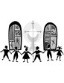
【Sunday Service Schedule】
Date/ Responsibility | 01/25/09 | 02/01/09
Speaker | Mr. Joe Karlya | Rev. Johnson Yu
Presider* | Sunny Shih | Rebecca Lin
Praise Team Leader** | Jeffrey Yu | Samantha Yu
Offertory Collector/Prayer | Lily Pan | Andrew Tan
Sound Board | Daniel Chen | Torrance Pai
Power Point | Torrance Pai | Andrew Tan
Receptionist/Welcome | Andrew Tan | Lily Pan
Sunday School | Sunny Shih | Sunny Shih
*Presider needs to do: Call to Worship, Scripture Reading, and Announcements.
**Praise Team Leader needs to lead: Songs of Praise and Congregational Prayer.

Queens Taiwanese Evangelical Church
40-31 165th Street, Flushing, NY 11358
Week #4 Jan. 25, 2009

Theme of the Year
“Be a Disciple, and Make Disciples”

今年主題
【作門徒，帶門徒】

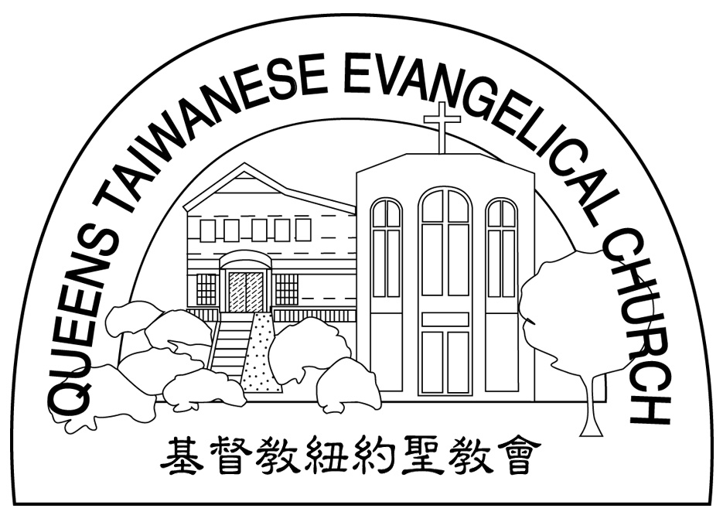
Verse of the Year主題金句
“Therefore go and make disciples of all nations,... teaching them to obey everything I have commanded you. And surely I am with you always, to the very end of the age.”
(Matthew 28:19-20)

Honored Pastor:高耀民牧師(Rev. Benjamin Kao) TEL: (718) 423-4550
Senior Pastor:尤陽生牧師(Rev. Johnson Yu) TEL: (718) 746-4199
Youth Director: 石松年弟兄(Sunny Shih) TEL:(518) 330-8447
Coworker of the Month:唐卓滿莉姊妹Mandy Chou) Tel:718-353-8610
Church Address: 40-31 165th Street Flushing, NY 11358
Church Website: www.qtecny.wtc.net
Church Telephone: (718)460-6326 ; FAX: (718)460-6326

Queens Taiwanese Evangelical Church
Week #4 Sunday Worship 01/25/2009

Presider: Sunny Shih Speaker: Mr. Joe Karlya

Call to Worship………..…“Psalm 103:17-19” ………Sunny Shih
Songs of Praise……………………………………...Praise Team
Congregational Prayer…………..…………………Jeffrey Yu
Tithes & Offering……………………………………Lily Pan
Testimony…………………………………………Jeffrey Yu
Scripture Reading………..“Romans 12:1-2”…………….… Sunny Shih
Sermon….……..…“Earmarks of a Believer”………....Joe Karlya
Song of Response ………………………….… Praise Team
Benediction…………………………………..….. Rev. Johnson Yu
Welcome & Announcements………………………Sunny Shih

“Do not conform any longer to the pattern of this world, but be
transformed by the renewing of your mind. Then you will be able
to test and approve what God's will is — his good, pleasing and
perfect will.”
(Romans 12:2)
【Key Verse of the Week】

QTEC SUNDAY WORSHIP SERVICE 01/25/2009
Speaker: Mr. Joe Karlya
Scripture: Romans 12:1-2
Sermon: “Earmarks of a Believer”
Notes:

- What does it mean to be a Believer?
- What does it mean to be “set apart”?
- What is Paul urging us to do here?

