
【Announcements】
- We thank Rev. Doug Estella for sharing God’s word with us today.
- If you have questions about Christianity, Church, the Bible, or issues pertaining to life and faith, please schedule an appointment with Sunny Shih.

- Our Youth Fellowship will meet this Friday at 6:30pm.

- There will be a special movie night outing next Sunday (Jan. 31st). We will watch ‘To Save A Life’ (which according to Sunny Shih is the best Christian film ever made).

- Please remember to pray for the victims of the recent natural disaster in Haiti. Our church has initiated a benevolent donation for helping the hundreds of thousands of orphans in Haiti because of natural disasters. Please specify your donation as “For Haiti” and give voluntarily and generously.
- Please continue to pray for Pastor Kao’s recovery, now in a rehabilitation center, and the sick and the weary, and those who are going through difficult situations.


- We welcome those who are here with us for the first time, and those who are visiting. We hope that you will continue to join us in worship in the future.

【Sunday Service Schedule】
 | 1/24/10 | 1/31/10
Speaker | Rev. Doug Estella | Sunny Shih
Presider | Daniel Chen | George Wang
Praise Team Leader | George Wang | Daniel Chen
Scripture Reading | Samantha Yu | Samantha Yu
Offertory Collector | Lily Pan | Lily Pan
Sound Board | Ken Wang | Ken Wang
PowerPoint | Andrew Tan | Andrew Tan
Receptionist/Welcome | Sarah Kim | Sarah Kim
Cleanup | Rachel Yeung | Rachel Chan
Sunday School (Adult) | Daniel Chen | Daniel Chen
Sunday School (Youth) | Sunny Shih | Sunny Shih

Queens Taiwanese Evangelical Church
40-31 165th Street, Flushing, NY 11358
Week #4 Jan. 24, 2010
Theme of the Year
“Deepen Worship, Vitalize Fellowship,
Strengthen Teamwork, Broaden Missions”
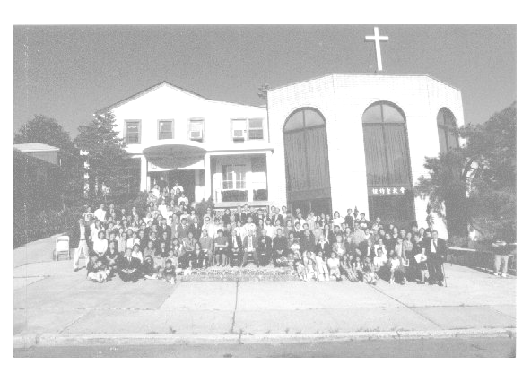

Verse of the Year
“And day by day, attending the temple together and breaking bread in their homes, they partook of food with glad and generous hearts, praising God and having favor with all the people. And the Lord added to their number day by day those who were being saved.” (Acts 2:46-47)

Honored Pastor:高耀民牧師(Rev. Benjamin Kao) TEL: (718) 423-4550
Senior Pastor:尤陽生牧師(Rev. Johnson Yu) TEL: (718) 746-4199
English Ministry Director: (Sunny Shih) TEL: (518) 330-8447
Coworker of the Month:王秀華姊妹(Hsiu Hwa Wang) TEL:(718) 591-1946
Church Address: 40-31 165th Street, Flushing, NY 11358
Church Telephone: (718)460-6326 Church Website:qtecny.wtc.net

Queens Taiwanese Evangelical Church
Week #4 Sunday Worship 1/24/2010

Presider: Daniel Chen Speaker: Rev. Doug Estella

Call to Worship .….…....”1 Peter 2:4-9”…...…... Daniel Chen
Songs of Praise………………………………….....Praise Team
Congregational Prayer…………………….……….… George Wang
Tithes & Offering………………………...……………….… Lily Pan
Scripture Reading ..…… “1 Corinthians 12:12-31a”….... Samantha Yu

Sermon.. “A Workable Metaphor for Gospel Community” .. Rev. Doug Estella
Song of Response …………………………..…... Praise Team
Benediction ……………………..………….…… Rev. Doug Estella
Welcome & Announcements …………………… Daniel Chen
【Key Verse of the Week】
“Be complete ly humble and gentle; be patient, bearing with one
another in love.”
(Ephesians 4:2)

ENGLISH WORSHIP SERVICE 1/24/2010
Speaker: Rev. Doug Estella
“A Workable Metaphor for Gospel Community”
Scripture: “1 Corinthians 12:12-31a”
Notes:

