基督教紐約聖教會三十週年感恩禮拜
QTEC 30th Anniversary Thanksgiving Ceremony

序樂 Prelude .……………………… Pianist Megan Chang司琴:張美琴
歡迎 Welcome……………………………Rev. Johnson Yu尤陽生牧師
頌讚 Praise……將天敞開Open Heaven………聯合敬拜團隊及會眾
祢真偉大How Great Thou Art Joint Worship Team
主我獻上生命給你I Offer My Life & Congregation
祈禱 Prayer.…………………………… Presider司會: Phil Sun孫瑞松
啟應及讀經 Responsive and Scripture Readings …………帶領者與會眾
啟：華語M:孫瑞松 台語T:簡英仁 English: Amanda Wu
獻詩 Anthem……Jesus Thank You感謝耶穌…EM Worship Team英語部敬拜團隊
信息 Message…「信心的功效」… Pastor Sorina Yang楊張秀蘭傳道
"The Effect of Faith" Translator翻譯: Jeffrey Yu尤立忠
影片Video.………兒童部Children Ministry.………SB/PPT音控/投影
見證Testimony.……………………….……….………Kelly Shi徐嘉莉
祝歌Anthem…沙頂的腳印Foot Prints in the Sand…Alumni新舊會友詩班
早期教會史Early Church History …………………Michael Lee李敏之
歷史回顧Historical Memories………影片Video..……SB/PPT音控/投影
祝賀Congratulatory…影片Video (鄒鎮民James Tzou)…SB/PPT音控/投影
獻詩 Anthem…信心的旅途Journey of Faith…QTEC Choir 聖教會詩班
致謝 Appreciation & Acknowledgement………………Rev. Yu尤陽生牧師
賀辭 Congratulatory Words…………………………………Presider司會
奉獻 Offertory……… 感謝神Thanks to God for My Redeemer ………會眾
司獻:華語M:曹林台英 English: Bridgeen Yap
報告 Announcements………………………………………Presider司會
宣揚 Proclamation………成為我異象Be Thou My Vision ………會眾祝禱 Benediction .…………………… Rev. Benjamin Kao高耀民牧師
殿樂 Postlude .…………………………… Megan Chang司琴:張美琴

- 1 -
啟應及讀經
詩Ps.104:1-2,5,14,33; 105:8-9; 提前1Tim.3:16;
太Mt.28:19-20; 可Mk.16:7a
（華語）
啟：耶和華我的 神啊！祢真偉大。
應：祢展開諸天好像鋪張帳幔，
啟：祢把大地堅立在根基上，
應：祢為了人的需用使糧食從地裡生出；
啟：我還在世的時候，要向我的 神歌頌，
應：祂永遠記念祂的約，就是與亞伯拉罕所立的約。
啟：敬虔的奧秘真偉大啊，這是眾人所公認的，
應：就是基督在肉身顯現，在聖靈裡稱義，
啟：被天使看見，被傳於列國，
應：被世人信服，被接到榮耀裏。
啟：所以，你們要去使萬民作我的門徒，
應：奉父、子、聖靈的名，給他們施洗，
啟：我所吩咐你們的一切，都要教導他們遵守。
應：這樣，我就常與你們同在，直到這世代的終結。
和：信的人必有神蹟隨著他們。

（台語）
啟：耶和華我的上帝啊，祢是至大！
應：祢展開天，親像帳幅，
啟：祢將地下佇伊的地基頂，
應：祢互食物對地裡出，做人的路用；
啟：我猶活的時，欲向我的上帝唱歌謳咾！
應：伊記念伊的約，直到永遠，就是及亞伯拉罕所立的約。

- 2 -

啟：大啊，敬虔的奧妙，無人呣掠做著！
應：就是基督顯現佇肉體，稱做義佇神，
啟：出現佇天使，宣傳佇外邦，
應：互人信佇世間，接納佇榮光。
啟：所以，恁著去招萬百姓來做學生，
應：給亻因行洗禮，互亻因歸佇父、子、聖神的名。
啟：見若我所有命令恁的，著教示亻因守，
應：閣我日日及恁佇口的，到世間的路尾。
和：信的人欲有諸個神蹟隨亻因。

(English)
Leader O Lord my God, you are very great!
Congre. You stretch out the heavens like a tent.
Leader You set the earth on its foundations,
Congre. You bring forth food for man from the earth.
Leader I will sing praise to my God while I have being.
Congre. He remembers his covenant forever,
the covenant that he made with Abraham.
Leader Great indeed, we confess, is the mystery of godliness:
Congre. He was manifested in the flesh, vindicated by the Spirit,
Leader seen by angels, proclaimed among the nations,
Congre. believed on in the world, taken up in glory.
Leader Go therefore and make disciples of all nations,
Congre. baptizing them in the name of the Father and of the Son
and of the Holy Spirit,
Leader teaching them to observe all that I have commanded you.
Congre. And behold, I am with you always, to the end of the age.
Together And these signs will accompany those who believe.
- 3 -
奉獻：感謝神

- 感謝神賜我救贖主，感謝神豐富預備，
感謝神過去的同在，感謝神主在我旁，
感謝神賜溫暖春天，感謝神淒涼秋景，
感謝神抹乾我眼淚，感謝神賜我安寧。
- 感謝神禱告蒙應允，感謝神未蒙垂聽，
感謝神我曾經風暴，感謝神豐富供應，
感謝神賜我苦與樂，在絕望裡得安慰，
感謝神賜無限恩典，感謝神無比慈愛。
- 感謝神賜路旁玫瑰，感謝神玫瑰有刺，
感謝神賜家庭溫暖，感謝神有福盼望，
感謝神賜喜樂憂愁，感謝神屬天平安，
感謝神賜明天盼望，要感謝直到永遠。

Thanks to God for My Redeemer

- Thanks to God for My Redeemer,
thanks for all Thou dost provide!
Thanks for times now but a memory,
thanks for Jesus by my side!
Thanks for pleasant, balmy springtime,
thanks for dark and dreary fall!
- 4 -

Thanks for tears by now forgotten,
thanks for peace within my soul!
- Thanks for prayers that Thou hast answered,
thanks for what Thou dost deny!
Thanks for storms that I have weathered,
thanks for all Thou dost supply!
Thanks for pain and thanks for pleasure,
thanks for comfort in despair!
Thanks for grace that none can measure,
thanks for love beyond compare!
- Thanks for roses by the wayside,
thanks for thorns their stems contain!
Thanks for homes and thanks for fireside,
thanks for hope, that sweet refrain!
Thanks for joy and thanks for sorrow,
thanks for heav'nly peace with Thee!
Thanks for hope in the tomorrow,
thanks through all eternity.

宣揚：成為我異象
1. 懇求心中王，成為我異象，萬事無所慕，惟主是希望！
願祢居首位，日夜導思想，工作或睡覺，慈容作我光。
2. 成為我智慧，成為我箴言，我願常跟隨，祢作我良伴。
祢是聖天父，我為祢後嗣，祢住我心殿，我與祢結連。
- 5 -

3. 財富非我求，虛榮非我慕，主是我基業，一直到永恆。
惟有主基督，能居我心中，祂是天上王，勝珍寶權能。
4. 天上大君王，輝煌的太陽，我贏得勝仗，天樂可分享。
境遇雖無常，但求心中王，掌管萬有王，永作我異象。

Be Thou My Vision
1. Be Thou my vision, O Lord of my heart;
Naught be all else to me, save that Thou art-
Thou my best thought, by day or by night,
waking or sleeping, Thy presence my light.
2. Be Thou my wisdom, and Thou my true Word;
I ever with Thee and Thou with me, Lord;
Thou my great Father, I Thy true son;
Thou in me dwelling, and I with Thee one.
3. Riches I heed not, nor man's empty praise,
Thou mine inheritance, now and always;
Thou and Thou only, first in my heart,
High King of heaven, my Treasure Thou art.
4. High King of heaven, my victory won,
May I reach heaven's joys, O bright heav'n's Sun!
Heart of my own heart, whatever befall,
Still be my Vision, O Ruler of all.

- 6 -

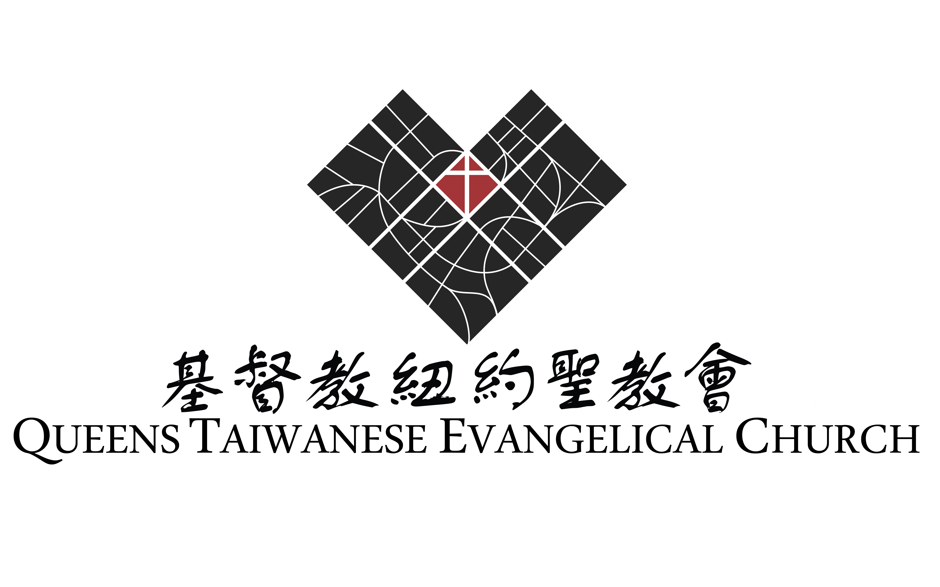

～～～謝謝您來參加感恩禮拜，與我們一同頌讚主恩！～～～
※ 會後有愛筵，請留步一起到本堂一樓享用。
※ 12/19-21有本會2014宣教年會暨佈道會，歡迎您參加。

Thank you for joining us in our celebration ceremony.
＊All are invited to a love feast on the first floor following the service.
＊You are also invited to our 2014 Mission and Gospel Conference
to be held on December 19-21.

基督教紐約聖教會設立三十週年感恩禮拜

時間：2014年11月29日下午3:00
地點：40-31 165TH Street, Flushing, NY11358

